***mSm***

**Hi** TannDiamond

® TannDiamond

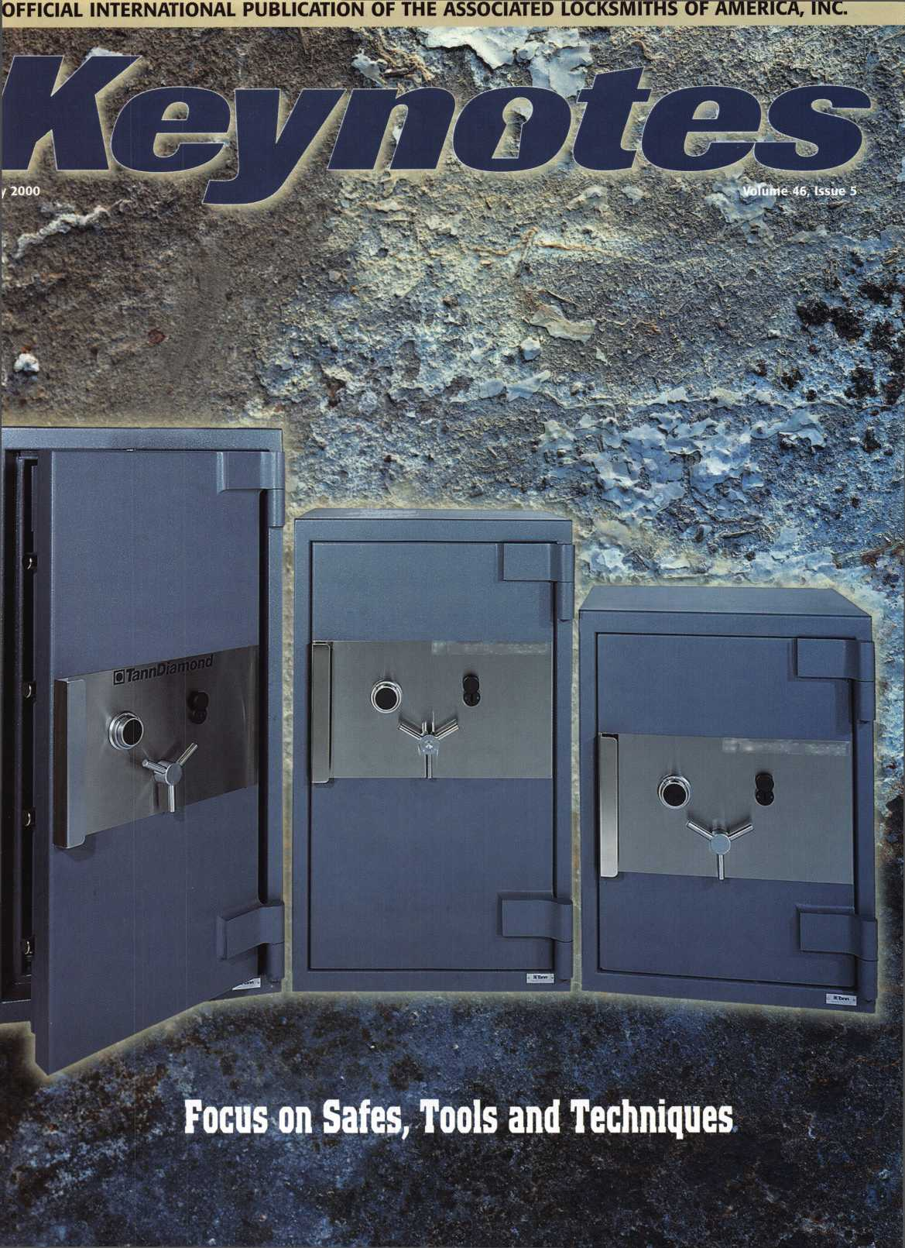

**There is nothing**

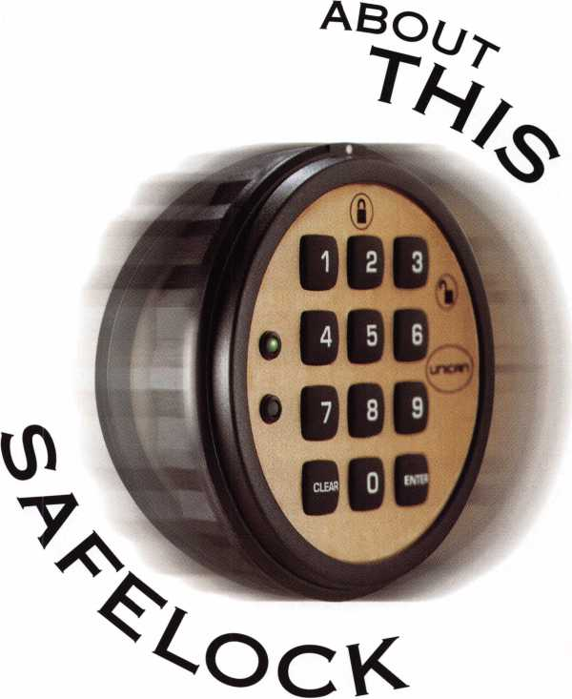

ORIGINAL

*u-ca*

***MlnlllSIMJInl***

for more information, call 800-849-8324 or visit our website at [www.ilcounican.com](http://www.ilcounican.com)

**It's patented inside and out.** It might look like all  
the others, but the electro-mechanical SAFELOCK 515  
is exceptionally engineered. Its patented design  
includes Convert-A-Bolt™ technology for field-selectable

deadbolt / springbolt. **It's packed with features.** UL

listed Type 1, the SAFELOCK 515 features include four security levels and  
programmable dual custody, time delay, open window, tamper shutdown,  
and lockout. **And it costs less.** The SAFELOCK 515 is fully programmable  
from the keypad, requiring no distributor programming fees, expensive  
modules, or hand-held programmers. With more security for less investment,  
the SAFELOCK 515 is the ideal choice.

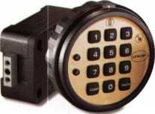

**May** 00

**Volume 46, Issue 5**



Features

4

President’s Journey

Other industry related organizations bring input and cooperation.

18

Roadmap to Success

conclusion of one man’s rise to success.

By Claire L. Cohen, CML

Mosler Question

What options do safe technicians have when it comes to working with the

302?

By Don Dennis

20

Change Key Sets

Make sure you have the right tools to open any type of mechanical safe lock.

By Sal Dulcamara, CML

When is a Simple Combination Change NOT Simple?

Always! There is a lot more to combination changing than meets the eye.  
Learn the proper combination changing techniques and what to do when

things go wrong.

By Brian Costley, CML, CMS

34

Legislative Update

The More Things Stay the Same

A reflection on past licensing and an update on bills that saw movement in March and April.

The Cover

When a customer calls for help with a combination change are you ready? Do you have the right change keys? This month, we address the types of change keys needed for different jobs and the proper combination changing techniques.

Cover Credit

Cover photos supplied by ALOA member Defiant Safe - Dallas, Texas Photography by Jim Wilson - Dallas, Texas

Art direction/design Phoenix Concepts

972.479.9026 ConQuest Graphixs 817.285.0003



Keynotes

May 2000

**Departments**

Upcoming Events

Security Marketplace

Applicants for Membership

44

Back Page

36

Classifieds

38

Associate Members

42

Ad Index

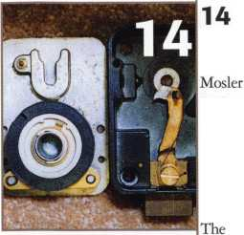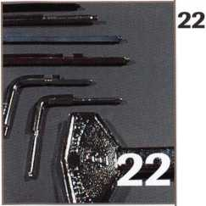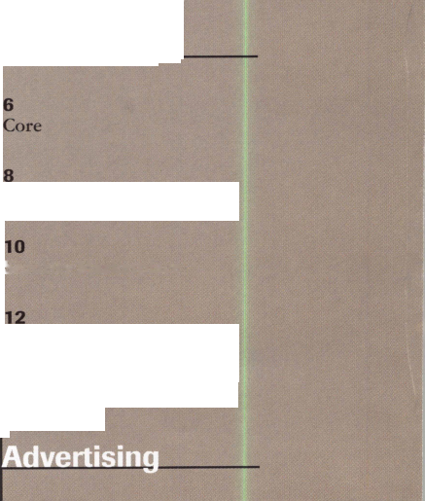

Communications/Financial Coordinator Editorial Advisor

Advertising Sales

Contributing Editors

Contributing Authors

Patanya Johnson

John D. Cannon, CML

[jdcannon@worldnet.att.net](mailto:jdcannon@worldnet.att.net)

Marvin Diamond

Native American Journal Co.

(706) 782-0878

[thediamonds@mindspring.com](mailto:thediamonds@mindspring.com)

Paul Chandler, CRL

Claire Cohen, CML

Sal Dulcamaro, CML

Jerome V. Andrews, CML

Brian Costley, CML, CMS

Bob De Weese, CPL

Ray D’Adamo, CML

Michael A. Ferrill

James Glazier, CML

Daniel Graffeo, CRL, CMS

Wayne Gurnee, CRL

A.J. Hoffman, CML

Ken Holmlund, CRL

Ray Lusk, CML

Mark Ohno

Randy Simpson, CML

Robert Stafford, CPL

Dave Thielen, CML

Additional contact information for the ALOA Board and most Keynotes authors is available through “Locksmith Search”' on the ALOA website- [www.aioa.org](http://www.aioa.org) or by contacting the ALOA office at 3003 Live Oak Street; Dallas; TX 75204; C800J532-2562;

FAX (214)827-1810; e-mail [aloa@aloa.org](mailto:aloa@aloa.org).

President

John J. Greenan, CML, CPS (773) 486-2030

Secretary

John D. Cannon, CML (703) 960-6413

Directors, Northeast

James H. Glazier, CML (301) 831-5454 John C. Magee, III

1. 845-3434 William L Young, CML
2. ) 647-5042

Directors, Southeast

Thomas W. Tate (850) 476-4211 Donald E. Rule, CML (601) 324-2658

Directors, North Central

Mark E. Blum, CML, CPS (517) 482-5809 Tom Ripp, CRL (608) 262-3831

ALOA Professional Staff  
Executive Director

Operations Manager

Comptroller  
Government Affairs Manager

PRP/Education Manager

PRP/Education Coordinator  
Membership Coordinator  
Meetings Coordinator  
Chapters & Regional  
Associations Liaison

Information Systems Manager  
Receptionist

Charles W. Gibson, Jr., CAE [charlie@aloa.ioffice.com](mailto:charlie@aloa.ioffice.com) Mary May

[mary@aloa.ioffice.com](mailto:mary@aloa.ioffice.com) Kathy J. Romo Tim McMullen [tim@aloa.ioffice.com](mailto:tim@aloa.ioffice.com) David Lowell, CML, CMS [david@aloa.iofifice.com](mailto:david@aloa.iofifice.com) Ashley Spencer Shelly Jett Thom Terry

Tim McMullen [tim@aloa.ioffice.com](mailto:tim@aloa.ioffice.com) Randy McChristian Barbara Ortiz



Mission Statement: The Associated Locksmiths of America, Inc. is dedicated to enhancing the professionalism, education and ethics among locksmiths and those in related sectors of the physical security industry. With approximately 10,000 members in the United States, Canada and the freeworld, ALOA is poised to help members obtain the knowledge, the strength, and the confidence to perform their role in the physical security field with pride and dignity. But it is only through active involvement and participation that ALOA can fully achieve its potential-and can help members to achieve theirs.

Policies: Keynoted is the official publication of the Associated Locksmiths of America, Inc. (ALOA). Keynotes® acts as a moderator without approving, disapproving, or guaranteeing the validity or accuracy of any data, claim, or opinion appearing under a byline or obtained or quoted from an acknowledged source. The opinions expressed by the authors do not necessarily reflect the official views of ALOA. Also, appearance of advertisements and new products or service information does not constitute an endorsement of products or services featured by the Association. The Association does not accept responsibility for the inaccuracy of any data, claim, or opinion appearing in this publication, due to typographical errors on the part of the authors, Association staff or its agents. Editor’s Note: This publication is designed to provide accurate and authoritative information in regard to the subject matter covered. It is provided and disseminated with the understanding that the publisher is not engaged in rendering legal or other professional services. If legal advice and other expert assistance is required, the services of a competent professional should be sought.

Authors’ Payment: Payment for eligible submissions to Keynotes will be based on the following criteria: topic, time spent and past contributions. Authors who regularly submit to Keynotes are generally paid a higher rate. The latter is especially true of authors who write to fit specific editorial needs and submit said copy by Keynotes deadlines. As a general guideline: Average payment for a 750 word, business or ‘light’ technical article would be $200. Payment for a 1500 word article involving significantly higher time and research efforts would be $400.

Payment will not be offered for articles submitted by ALOA employees or members of the ALOA Board of Directors (unless material is of a technical nature), nor for articles submitted by a company that promote that company’s products or services. ALOA reserves the right not to pay for articles submitted by an individual® that promote a particular company’s products or services.

Disclaimer: The Associated Locksmiths of America, Inc., (ALOA), reserves the right to refuse any article for any reason. Additionally, ALOA reserves the right to edit, amend or modify any article submitted for publication in order to preserve technical accuracy, clarity, fairness or grammatical correctness. ALOA will make the best efforts to notify the author of any changes. The extent of ALOA’s liability for any article or information contained therein will be a notice of correction or retraction in the next possible issue.

Keynotef (ISSN 0277 0792) is published monthly except for the combined June/July issue by The Associated Locksmiths of America, Inc., 3003 Live Oak St., Dallas, TX 75204-6186. Telephone: (214) 827-1701; FAX (214) 827-1810; e-mail [aloa@aloa.org](mailto:aloa@aloa.org). Subscription rates for members-$15.00 per year. Second class postage paid at Dallas, Texas. POSTMASTER: Send address changes to: Keynotes, 3003 Live Oak St., Dallas, TX 75204-6186. © Copyright 1999, All rights reserved. No part of the contents may be reproduced or reprinted in any form without prior written permission of the publisher.

Director, South Central

Randy L. Simpson, CML (713) 780-7026

Directors, Southwest

Gordon R. Racine, CML (719) 384-4707 John A. Ilk CRL (602) 420-2174

Director, Northwest

Scott L. Henke, CRL, CPS (907) 248-3785

Director, Associate Members

Judd Penske (800) 634-5465

Trustees

Dallas Brooks

(334) 826-8990

David M. Lowell, CML, CMS

(800) 532-2562

Breck H. Camp, CML

(770) 455-6244

Edwin Toepfer, RL

(416) 225-5589

Past Presidents

1997-1999 Dallas C. Brooks 1995-1997 David Lowell, CML, CMS 1993-1995 Breck Camp, CML 1991-1993 Henry Printz, CML 1989-1991 Evelyn Wersonick CML, CPS 1987-1989 Leonard Passarello, CPL 1985-1987 Joe Jackman, CML 1983-1985 Stanley Haney, CPL 1981-1983 Louis LaGreco, CPL 1979-1981 John Kerr, RL 1977-1979 Clifford Cox, CML 1974-1977 Charles Hetherington 1972-1974 Gene Laughridge 1970-1972 William Dutcher, RL 1968-1970 Constant Maffrey, RL 1966-1968 Harold Edelstein, RL 1964-1966 William Meacham 1962-1964 Robert Rackliffe, CPL 1960-1962 Edwin Toepfer, RL 1956-1960 Ernest Johannesen

May 2000

Keynotes li

with John J. Greenan

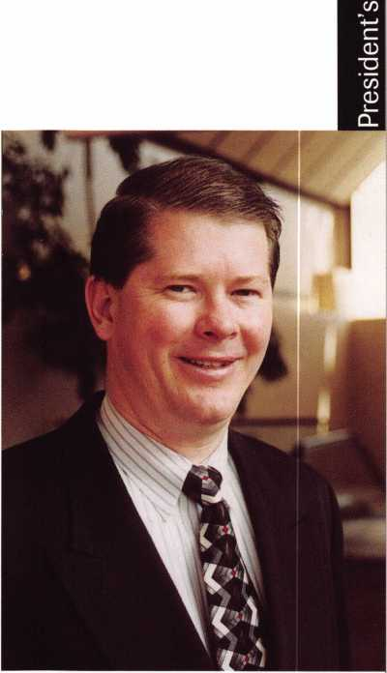

The ALOA Board held the Spring Board Meeting in Las Vegas, NV, the site of the ALOA 2000 Convention and Security Expo, July 24-30, 2000. One of the Board’s goals is to have input from other industry related organizations at board meetings. This gives the board members more information on which to base decisions. At the meeting we had several guests, including the president of the Safe and Vault Technicians Association, Skip Eckert; the president of the Institutional Locksmiths Association, Phillip Rovenolt and the president of the National Burglar and Fire Alarm Association, Dan Jacquish. I thank these gentlemen for providing information and insight to the ALOA Board to help in planning the future of ALOA.

Another of the board’s goals is to become more cooperative with state and local associations, particularly where education and legislation are concerned. We have developed the Affiliate Association Program to address this goal. The purpose of this program is to create an avenue for the exchange of information and ideas between local associations and ALOA. We will be sending out more information to all of the locksmith associations very soon.

In April, I attended the Master Locksmiths Association of New Jersey’s convention. This was a great opportunity to meet members and other locksmiths and to gain insight into the concerns they have about ALOA and our industry in general. The Saturday evening Gala banquet was terrific as always, Nick Ambrosi and his group did another outstanding job, it was really a first class affair. I was very fortunate to be seated with Martin Jordan from Gorman, Maine, and Jim Dunlap from Arlington, Va., who were attending the convention for the first time. We had a wonderful evening. If you have never attended an MLANJ Convention, you should make a point of going.

ALOA will also have representation at the Security Hardware Distributors Association (SHDA) meeting. Formerly known as the Locksmith Suppliers Distributors Association, they recently changed their name to SHDA. Speaking of changing names, I would like to thank everyone who responded to my editorial about changing the name of our association. I received a lot of good information and some very good suggestions. Kim Koehlinger of Fort Wayne, Ind., suggested IITASPA, International Incredibly Talented and Amazing Security Professionals Association. Thanks to Kim, but I think we’re going to have to give it a little more thought.

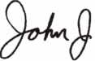

*'AJL£a*jA*\.*

John J. Greenan, CML, CPS

May 2000

I Keynotes



**A duplicate key can come back to bite you.**

^ E V E R E S T„| introducing a new patented key control system

from the industry leader in life safety and security. Schlage's Everest™ family  
features a distinctive new key and includes a complete line of open and restricted  
keyways, allowing you to select the level of key control you desire. The Everest  
product line is protected by new utility patents to prevent the manufacture and  
distribution of aftermarket key blanks by anyone else but Schlage. A full range  
of Everest cylinders and locksets are available to retrofit into your existing door  
hardware or for new construction. Find out how Schlage can assist you in  
managing your key system to improve security. Call us

at 1-800-847-1864 for more information.

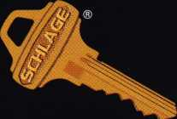

INGERSOLL-RAND

**ARCHITECTURAL HARDWARE**

Ingersoll-Rand Architectural Hardware Group, Schlage Commercial Lock Division ©1999 Ingersoll-Rand

**SCHLAGE**

***Qain control***. ***Keep control***.

core

* Lockpicking Devices Prohibited on eBay

Several months ago, ALOA contacted eBay, the online auctioning website regarding our concern over the listing of lockpicking devices. Recently, the General Counsel of eBay contacted ALOA to report that the listing of such items on their site is now a prohibited activity. They have made a good attempt at limiting these items (they still list them, but you cannot bid on them). However, they cannot monitor their site 24/7, and have asked us to notify them of violators by emailing: [ctywatch@ebay.com](mailto:ctywatch@ebay.com).

For more information see:

<http://pages.ebay.com/help/community/png-lockpicking.html>

The sale of lockpicking devices is highly regulated within the United States. In addition, federal law prohibits interstate mailing of locksmithing devices, violation of which is a misdemeanor. Locksmithing devices can also only be sold to authorized recipients. Since the majority of merchandise is delivered by mail and it is difficult to verify the person is authorized, the sale of locksmithing devices is not allowed on eBay.

For more information, visit:

<http://www4.law.cornell.edu/uscode/39/3002a.html> <http://www4.law.cornell.edu/uscode/18/17l6A.html> eBay policy

eBay does not permit the listing of any lockpicking or locksmithing device such as lock picks, lock picking sets, lockpicking cards, tension bars, lock picking guns, autolock bypass keys (“jigglers”), try-out keys, “slim-jims,” tubular lock picks, digital decoders and code grabbing devices.

* SpectaGuard Acquires Allied Security

SpectaGuard, a leading security services firm has acquired Allied Security, a national security firm located in Pittsburg, PA, creating Allied-SpectaGuard, the largest privately held security services firm in the U.S. The company reports 1999 annual revenues of more than $378 million, 16,000 employees and a network of 47 offices serving U.S. major markets. The acquisition marks a continued consolidation of the largest companies in the $16 billion U.S. security services industry. Allied-SpectaGuard is the fourth largest of all security companies in the U. S.

• Show Me The Money

ALOA will show some lucky attendee to the ALOA 2000 International Convention and Security Expo in Las Vegas, NV, the money! ALOA will be giving away $ 1,000 per hour on the last day of the trade show, July 30, at the Las Vegas Convention Center. You must be a registered attendee and on the show floor to win!

* llco Purchases Mas-Hamilton

Ilco Uncian purchased the Mas-Hamilton Group at the end of March. Mas-Hamilton will continue to operate out of Lexington, Kentucky as a wholly owned subsidiary of Ilco with continued emphasis on product innovation, market development and customer service.

* Akron Adds Folger Adam

Akron Hardware, the largest distributor of Yale Security hardware lines has recently added the Folger Adam product line to their inventory. The Folger Adam line of electric strikes as well as Corbin Russwin, Yale, Norton and Rixson product lines are in stock at both Akron Hardware locations.

* RCI Doubles Size of Facility

Rutherford Controls International Corp recently expanded their manufacturing facility, doubling the size of the plant. The expansion also includes the completed acquisition of a metal fabrication plant. This gives RCI the opportunity to offer higher quality and efficiency along with faster product delivery. RCI has been in operation since 1923 and provides the security industry with access control products and has distribution outlets across the United States, Canada, Mexico, Central and South America.

* Regions

The Oklahoma Master Locksmith Association (OMLA) has launched its web site at <http://www.omla.com>.

The Fox Valley Chapter of ALOA has elected new officers. Mike Zurawski, Chairman; Norm Zurawski,

Vice-Chairman; and Bob Erdmann, Secretary/Treasurer.

East Tennessee Locksmith Association (ETLA) monthly membership meeting will be held May 18th at Henry Peter’s house at 7 p.m. The program will be a class on Automotive Update information/tips and tricks. [whitenightlock@aol.com](mailto:whitenightlock@aol.com)

Keynotes

May 2000

The Association of Ontario Locksmiths (TAOL) is in the process of arranging the educational classes for their 2000 convention to be held in September. The following is a list of classes being considered, Tips and Tricks of the Trade, Safe Deposit Boxes, Basic Alarms, Safe Manipulation, Investigative Locksmithing #3, The Installation of Annunciator Buttons, High Security Auto, Auto Opening and Tubular Lock Ace, Gem, etc. If you would like to participate in the above classes or suggest others please contact the TAOL office at (888) 272-8265.

The New Mexico Locksmith Associations 2000 Annual Convention and Classes will be held June 7-11, 2000 at the Ramada Mountainview Hotel in Albuquerque, NM.

(Editor’s note: Would you like to see your regional association’s activities represented in Keynotes: Just fax all correspondence to 214-827-1810 or email to: keynotes@anet-dfw. com.)

* Elections

The President has called for a Special Meeting of the members at 10:00 a.m. on June 23, 2000 at the ALOA headquarters - 3003 Live Oak St., Dallas, Texas. Look for your vote-by-proxy in the June Keynotes.

* PRP

ALOA would like to congratulate the following individuals who have recently achieved new PRP designations.

CRL

Shimshon Alpert, Lancaster, PA Roy Brewster, Quaryville, PA

Christopher Griesbaum, Buffalo, NY Mark J. Hankes, Maperville, IL

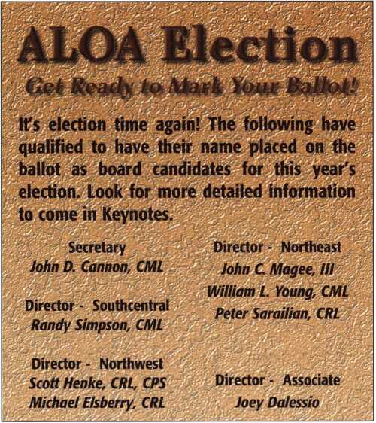

James Harvey, Mobile, AL Samuel Long, Louisville, KY

Michael G. Neill, Redford, MI Joseph Pielech, Tuscon, AZ David Redden, Hardinsburg, IN

Phillip A. Shooks, Kalamazoo, MI Michael Vorpahl, Oregon, WI Marlin Wigginton, Effingham, IL John Paul Williams, Nottingham, PA Scott Zawierucha, Hamburg, NY

CPS

Keven Broome, Hattiesburg, MS EXECS

Ingersoll-Rand is pleased to announce the election of Randy P. Smith to vice president of the company and president of Ingersoll’s Security and Safety Sector.

• Obituaries

ALOA sends its condolences to the family and friends of the following members:

Don E. Reese, who served as a loyal member for 36 years; Steve E. Raban, a member of ALOA for over 14 years and the past chairman of the Grand Canyon Chapter of ALOA; and James M. Baker, 34 of Chicago, II. who joined ALOA in May of 1999-

**TURPI lO**

**WHOLESALE SERVICE**

800**-**848-9790

One Call  
Gets You...

Amsec

•

Gardall

•

Hayman

Meilink

Victor

•

Winchester

Plus Free Delivery  
From America's  
Largest Inventory  
of Safes.

May 2000

Keynotes

Upcoming

Events



[Deptl

MAY

20

1-6

SAFETECH 2000 ^ STPRP/PRP Sitting Birmingham, AL Contact: Ashley Spencer (214)827-7233

1-12

Professional Locksmithing Technical Training

Nicholasville, KY

Locksmasters

(606)885-6041

(606) 887-0810 fax

Annual General Meeting of Japan Chapter Jal City, Nagasaki Japan Japan Chapter of ALOA Contact: Keizo Takahashi

81-45-582-4469

21

Nutmeg Chapter of ALOA Meriden, CT Motorcycle Locksmithing Contact: Roger Wechter, CPL (203) 845-8700

JUNE

[education@lockmasters.com](mailto:education@lockmasters.com)

6

Steve Young Class Aurora, CO

Central & Southern Colorado Locksmith Association RMLA

Contact: Barry (303) 688-4104

8-12

Security Management Training in

Physical Security

Hardware Evaluation

Security Surveys

Las Vegas, NV

Lockmasters

(606) 885-6041

(606) 887-0810 fax

[education@lockmasters.com](mailto:education@lockmasters.com)

9-10

ISC Expo Miami, FL (800) 840-5602 isc.reedexpo.com

12

ALOA PRP Sitting Dallas, TX

Contact: Ashley Spencer (214) 827-1701 (214) 827-1810 fax

12-14

North Carolina Quarterly Meeting Raleigh, NC

North Carolina Locksmith s Association (910)980-0901

15-17

Access Control Evaluation

Nicholasville, KY

Locksmasters

(606) 885-6041

(606) 887-0810 fax

[education@lockmasters.com](mailto:education@lockmasters.com)

17-20

ELF Convention Sofia, Bulgaria [www.bcci.bg/-clients/alob](http://www.bcci.bg/-clients/alob)

**8**1 **KeynotesMay 2000**

1

**ff\*** ALOA PRP Sitting New Orleans, LA IDN-Acme, Inc Contact: W Wayne Hilliars (504) 837-7315

1. 837-7321 fax

6-11

New Mexico Locksmith Association Albuquerque, NM 6 ACE classes and PRP Contact: Steve Smith

1. 281-6777

9

**^** ALOA PRP Sitting Dallas, TX

Contact: Ashley Spencer (214) 827-1701 (214) 827-1810 fax

1. 11

Ace Classes

ALOA PRP/STPRP Sitting Albuquerque, NM NMLA

Contact: Steve Smith (505) 681-6777

1. 11

Alabama Locksmith Association Montgomery, AL Small Format ICore Contact: Dallas Brooks (334) 826-8990

11

ALOA ACE Lititz, PA

High Security Cylinder Servicing Contact: Ashley Spencer (800) 532-2562 ext. 30

20-25

INTERSCHUTZ 2000 Augsburg, Germany US Dept of Commerce Contact: Donna Peterson Hyland (609) 987-1202 (609) 987-0092 fax [info@hfiisa.com](mailto:info@hfiisa.com)

Indicates ALOA ACE Class **fir** Indicates PRP Sitting

21-22

ISC Expo Chicago, IL (800)840-5602 isc.reedexpo.com

25

ALOA PRP Sitting Largo, MD

Institutional Locksmiths’ Association Contact: Philip Rovenolt (301)645-7786 (301)843- 9843 fax

JULY

14

ALOA PRP Sitting Dallas, TX

Contact: Ashley Spencer (214) 827-1701 (214) 827-1810 fax

24-30

ALOA 2000 Security Expo PRP/STPRP Sitting **£r\** Ace Classes Las Vegas, NV Contact: Ashley Spencer (214)827-1701

AUGUST

ii

ALOA PRP Sitting Dallas, TX

Contact: Ashley Spencer (214) 827-1701 (214) 827-1810 fex

20

ALOA PRP Sitting Ellicott, MD Clark Security Products Contact: Ron Cooling (858)974-5273 (858) 974-5284 fax

28-31

ISC Expo New York, NY (800)840-5602 isc.reedexpo.com

SEPTEMBER

7-9

DHI Convention San Francisco, CA Contact: Kathy Devey (703) 222-2010

8

/ALOA PRP Sitting Dallas, TX

Contact: Ashley Spencer (214) 827-1701 (214) 827-1810 fax

8-10

TAOL 27th Annual Convention Toronto, ON Canada Contact: Don DeKuyper

(416)321-2219 (888) 272-8265

8-10

Alabama Locksmith Association Gulf Shores, AL

Securitron Hands-on wiring class Automotive Field Servicing Techniques Contact: Dallas Brooks (334)826-8990

10

Nutmeg Chapter of ALOA Meriden, CT

Life Safety Codes and the ADA Contact: Roger Wechter, CPL (203) 845-8700

11-14

ASIS Convention Orlando, FL (703) 522-5800 [www.asisonline.org](http://www.asisonline.org)

17

**fk** ALOA PRP Sitting Buena Park, CA Clark Security Products Contact: Ron Cooling (858) 974-5273 (858) 974-5284 fax

20-24

GPLA **50+1** Convention **fk** ALOA PRP Sitting Philadelphia, PA Contact: Nelson Dayton **(610)688-9188** [www.gpla.org](http://www.gpla.org)

23

Grand Canyon Chapter of ALOA Phoenix, AZ

Professional By Pass Techniques Contact: John Ilk (480) 967-1876

29-OcL 1

National Trade Show & Educational Seminar Jo-Van Distributors Inc. (Toronto)

Contact: Larry

(416) 752-7249

30

**fk** ALOA PRP Sitting Kansas City, MO

Missouri-Kansas Locksmith Association Contact: Bob Turner (816) 525-5522 (816) 525-8628 fax

OCTOBER

13

**fk** ALOA PRP Sitting Dallas, TX

Contact: Ashley Spencer (214) 827-1701 (214) 827-1810 fax

13-15

SERLAC **\^T\** Ace Classes Jacksonville, FL Contact: James Riley (941) 294-8679

14

jj^PRP Sitting Colorado Springs, CO

Central & Southern Colorado Locksmith Association Contact: Rick Dyer, CRL (719) 282-0360 (877) 694-6011 fax

23-27

Tri-Regional Show Seattle, WA

Contact: Robert Kotovic (847) 692-5940

NOVEMBER

1-4

Yankee Security Convention Sturbridge, MA 15 ACE classes and PRP Contact: Steve McKinney (508) 541-8945

6-10

Yankee Security Conference Sturbridge, MA (800) 209-8266

10

**fk** ALOA PRP Sitting Dallas, TX

Contact: Ashley Spencer (214) 827-1701 (214) 827-1810 fax

DECEMBER

8

**fk** ALOA PRP Sitting Dallas, TX

Contact: Ashley Spencer (214) 827-1701 (214) 827-1810 fax

2001

FEBRUARY

3

Alabama Locksmith Association Birmingham, AL Electronic Safe Lock Class Contact: Dallas Brooks (334)826-8990

MARCH

28-April 1

MLANJ 2001 Annual Convention Ace Classes **fk** PRP Sitting Somerset, NJ (973) 267-8884 (973) 538-2248 fax [www.mlanj.org](http://www.mlanj.org)



At Stone & Bog, we pride ourselves in having more than 5,500 different llco Unican key blanks in stock at one time. So we’re ready when you need us most. Whether you have a call for ahard-to-find key blank or one of die popular llco Unican key numbers. Stone & Berg is ready to fill .the order. And we are constantly updating our llco key blank invent­ory. That's how we stay ahead of the competition.

And that's how we’ll help you stay ahead of yours. So call us when you need it, and it will be there.

That’s the 30 years of Stone &

Berg tradition you’ve come to trust.



**Stone & Berg**

Wholesale Locksmith Supply Company

(800) 225-7405 • Fax: (800) 535-5625

May 2000

***Keynotes***



Security

Marketplace

SPEEDYPIK

SPEEDYPIK has added an Automatic Key Coder to it’s line of Automatic Key Identification systems. The new system will eliminate the need to measure the cuts in a key, or eyeball the cuts. This will completely eliminate guessing or training an apprentice to learn the pinning charts. After you dial the lock company and scroll down to the exact key series, just insert the key and a manufacturers readout will tell you what the cuts are starting from either tip to bow or bow to tip. This scan and readout will only take a few seconds. This unit is portable, hand held battery operated and rechargeable. The Decoder can be plugged into a computer through the serial port or connected to a computerized code cutter. You can add manufacturers spacings and depths then download them through your computer. This unit has a double line readout that displays the manufacturers name, lock series and key name on one line.

The second line tells you if its a Double or a Single sided key and the depth numbers starting either from tip to bow or vice versa. This will be added to our website in detail and a demo alongside the Key ID demo.

SPEEDYPIK Corp.

378 Washington Street

Woburn, MA 01801

http:H [www.SPEEDYPIK](http://www.SPEEDYPIK). COM

(617)567-1111

(617) 277-7777 fax

CrediPort Systems Inc.

CrediPort Systems has announced the immediate availability of the first ever wireless checkreader. It is combined with their cellular wireless credit card verification system.

The patent pending CrediPort Safechek consists of a terminal/printer, a check reader, a powerful rechargeable battery and a three watt cellular telephone. It is packaged in a nylon carrying case. Dimensions are 11.5” X 9” X 5” and it weighs under 9.5 lbs.

Upon delivery the CrediPort System is already cellular enacted and credit card/check ready.

CrediPort Systems Inc.

6489 Ridings Road Syracuse, NY 13206 http: I **/** www. crediport. com (315) 437-7556 (315) 463-1533 fax



Adrian Steel Company

Adrian Steel Company recently announced a new edition to the ‘Steeler’ line pickup ladder racks. The ‘Load Runner’ pickup rack features an aerodynamic tubular steel construction.

It is designed to fit all full-size pickups and provides 750 pounds of carrying capacity while complimenting newer pickup truck styles. ‘Load Runner’ models for 6.5’ or 8’ pickup bed lengths in regular cab or extended cab-over styles are available. The racks come with a glossy black ‘Steel-Cote’ powder coat paint with a G-60 galvanized undercoat for weather resistance.

Adrian Steel Company 906James Street Adrian, Ml 49221-3996 http:! I[www.adriansteel.com](http://www.adriansteel.com) (800) 677-2726

Instrument Technology, Inc.

New from Instrument Technology,

Inc. (ITI), a Reverse Peephole Scope that allows viewing into rooms equipped with a peephole in the door. The front end of the scope is cushioned for quiet operation. The peephole scope is designed for daytime operation or when there is light in the room, but is adaptable to video and night vision systems with optional adapters.

Instrument Technology, Inc.

PO Box 381, 33 Airport Road Westfield, MA 01085 http: 11 www. scopes, com (413) 562-3606

1. 568-9809 fax

STRATTEC Security Corporation

STRATTEC has released the STRAT-a-Various universal pinning kit. STRAT-a-Various contains all of the tumblers, springs and spring retainers necessary to assemble Chrysler, Ford, General Motors and Mitsubishi lock service packages on many vehicles for which STRATTEC is the original equipment supplier. The kit provides components for the following lock sets: Chrysler double sided, Ford 8-cut,

General Motors single and double sided

and Mitsubishi. STRAT-a-Various, part

number 705940, may be ordered from

authorized STRATTEC distributors.

STRATTEC

3333 W. Good Hope Rd

Milwaukee, Wl 53209

1. 247-3333 (414) 247-3329

Alpha Systems Lab, Inc. (ASL)

ASL has introduced the world’s first modular PC-based remote surveillance system. Remote Watch Millennium is the first totally modular digital video system. It operates on one proprietary software platform, yet is fully customizable and upgradeable. This ‘building block’ design offers the opportunity to acquire the base system, with the flexibility to add features, benefits and capacity as needs expand.

Alpha Systems hah 17712 Mitchell North Irvine, CA 92614 (949) 622-0688 (949) 252-0887 fax

Panasonic

Panasonic Security & Digital Imaging Company (PSDI), Security Systems Group has commenced shipment of the new WJ-SX350 Matrix Switcher. The new addition provides users with advanced features and functions for small scale CCTV systems. The WV-SX350 Matrix System provides control of up to 32 cameras, eight monitors and four system controllers with extensive programma­bility. The unit features versatile camera switching modes including 32 tour sequences and group switching sequences. Additional features include three alarm modes, system partitioning and priority access codes with password protection.

The system also offers RS-485 protocol and provides direct remote control of all Panasonic cameras accepting RS485 input. When used in conjunction with the WJ-MP204, it is possible to control all Panasonic cameras that have remote control capabilities. Accessible functions include sense up, shutter and AGC control, as well as pan/tilt/zoom, iris and focus control.

Panasonic Surveillance Products

(888) PAN-CCTV

http: I **/** [www.panason](http://www.panason) ic. com I cc tv

Kwikset

Kwickset introduces premium door hardware with the new Satin Nickel Finish available on the TITAN Society Brass Collection. The entire collection is now available with satin nickel finish. This includes the Windham knob, Pembroke and Fremont levers, Shelburne, Amherst, Wellington and Hawthorne handle sets. The collection features solid brass construction and a lifetime mechanical warranty. The Society Brass Collection is also available in five other finishes; Polished Brass, Antique Brass, Antique Nickel,

Dark Bronze and Polished Chrome.

***Keynotes***

May 2000

Titan is the premium brand from the Kwikset Corporation. Titan products are available at most home centers and hardware stores.

Kwikset Corporation 516 E Santa Ana Street Anaheim, CA 92803-4250 (7140 535-8111 (800) 327-LOCk http: 11 www. kwikset. com www. kwikset. com

Von Duprin Division Ingersoll-Rand Company

Von Duprin has introduced a new code-compliant exit alarm lock that provides secure, alarmed protection for secondary exits, perimeter doors, back doors and other emergency exits. The GUARD-X readily identifies the door on which its mounted as an emergency exit and secures opening against unauthorized use. It is a fully code compliant exit lock that provides a combination of alarm and deadbolt functions that complement the existing Von Duprin Chexit(r) controlled exit device and ALK exit device alarm kit. The exit alarm has a large stainless steel deadbolt that engages over 1.25 square inches into the strike and is guarded by a cast aluminum latch.

Yon Duprin Division Ingersoll-Rand Company 2720 Tobey Dr Indianapolis, In 46219 (317) 897-9944 (317) 899-9302 fax

Meilink Safe Company

Meilink Safe Company has announced that their previously non-rated Winchester Legacy Safe has been redesigned and now carries the Omega Point Laboratories certified 1200 degree/1/2-hour fire safe label, and the Underwriters Laboratories Gun Safe rating.

The Winchester Legacy safe comes in two sizes (60” x 30” and 60” x 40”) with a variety of interior configurations. They are available in either a gloss coat finish or a mar-resistant textured finish.

Ducks Unlimited (DU) editions of the safe are also available in both models. Meilink

111 Security Parkway New Albany, IN 47150 (812) 941-1655 (8000 494-6723 (812) 948-0437 fax

NAPCO Security Group

NAPCO announced the addition of Single and Double Action Pull Stations to its line of Firewolf Fire Products. Model FW-PULL1 is a single action device that is reset with a screwdriver. Constructed of durable aluminum, the Firewolf FW-Series Pull provide manual fire reporting and are part of the UL-Crosslisted line of NAPCO Firewolf initiating devices and notification appliances. (UL and ULC-listed). NAPCO

(80) 645-9445 Ext. 64

Olympus America Inc.

Olympus America Inc., Industrial Products Group (IPG) has introduced a compact portable image storage system. Attached to rigid or flexible borescopes, the DC-10 QuikStore system allows inspectors to view, freeze, store, export and email images. The DC-1- QuickSore comes with a FlashPath card and adapter. It has an integrated screen, designed with a sun visor to eliminate glare for viewing.

The system can also be used with new Olympus EYE-TREK glasses.

Olympus Industrial Products Group Two Corporate Center Drive Melville, NY 11747-3157 www. olympusipg. com

Security Door Controls

The new SDC 602RF modular power supply is designed for use with access controls and electric locking hardware. UL Listings include Access Control Systems Unit, Fire and Burglary Alarm Power supply and releasing device accessory. Features include 1 Amp Output, field detectable 12/24/VDU, fore emergency release input, choice of 10 relay modules, battery charger and low battery disconnect. The specified secondary output is maintained while charging.

Security Door Controls

3580 Willow Lane

Westlake Village, CA 91361-4921

(805) 494-0622

(805) 494-8861 fax

Jet Hardware

Jet Hardware recently announced their ETD-l-JR affordable alternative model of the electronic Transponder and duplicator. It is designed for duplication only and cannot be linked to a PC for storage. The ETD-l-JR will clone all programmable Transponder keys and includes both AC adapter and a 9-volt battery pack. The H86-PHT Transponder key to fit the new Ford Focus is now available.

Jet Hardware 800 Hinsdale St.

Brooklyn, NY 11207



SECURITy

LOCK COMPANY

**New** Factory Replacement Parts and Locks for Security Corporation and Kumahira Safe Co. Products

* Safe Deposit Box Locks and Parts BX, KD
* Automatic Remote Tube Systems (ARTS)
* Drive Up Systems
* Vault Doors
* Night Depositories
* Camera Systems
* Key Blanks and
* Keys Cut to Code

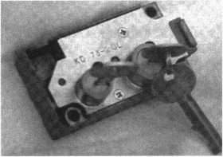

KD Series

Safe Deposit Box Locks

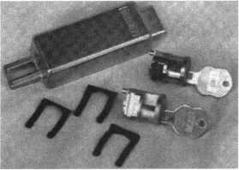

BX Series Safe Deposit Locks

1155 Chess Drive, #114 Foster City, CA 94404 Phone: (650) 525-0660 Fax: (650) 525-0444

Email:

[chaslutz@securitylockco.com](mailto:chaslutz@securitylockco.com)



SECURITy

LOCK COMPANY

May 2000 Keynotes L_

Applicants

For Membership

Dept

***W The following applicants are scheduled for clearance as members of ALOA. The names are published for member review and comment prior to June 1, 2000, respectively, to ensure applicants meet standards of ALOA’s Code of Ethics. Protests, if any, should be addressed to the Membership Department and must be signed. Active Membership applicants (A) have worked in the industry two or more years. Allied Membership (AL) applicants are not locksmiths, but work in a security-related field. Apprentice Membership (AP) applicants have worked in the industry less than two years.***

APO

Thurman D Dunlow Jr

ALASKA

Anchorage

Carl J Roehl

ALABAMA

Birmingham

Wendell Walker

Hueytown

Louis E. Phillips

Huntsville

Allen Blake Charles Roe

ARIZONA

Mesa

Rene Dekker

CALIFORNIA

Barstow

Brenda Santiago

West Hollywood

Sean Olden

COLORADO

Colorado Springs

Peter W Ordway

FLORIDA

Palmetto

Clay L Cairl

Plantation

Valerie A Tannenbaum

GEORGIA

Atlanta

Dale M Dylong

Gainesville

John Carroll

HAWIAII

Honolulu

Sherwood T Hanson

IDAHO

Idaho Falls

Doreen K Jonak

ILLINOIS

Batavia

Lonnie L LaSourd

Chicago

Demetrius Palacios

Crystal Lake

Michael C Philpot

|  |  |  |
| --- | --- | --- |
| Hinsdale | Brooklyn | WISCONSIN |
| Eric C Johnson | Ayman M Hassan | Beloit |
| Oak Lawn | Selden | Mark D Ryan |
| Karl E Watson | Roseanna Zimlinghaus |  |
| INDIANA | Springville | Bahamas |
| Clarksville | David C Swanson | Nassau |
| Jerry L Walker | OKLAHOMA | Audley S Humes |
| Merrillville | Hominy |  |
| Allan C Brandy | Larry D Charlton | Canada |
| Valparaiso | Sapulpa | BC |
| Carl H Hoefler | Michael A Goad | Port Moody |
| MARYLAND | PENNSYLVANIA | Earl K Flood |
| Hagerstown | Lititz |  |
| Roy N Jones | Roy E Brewster II, CRL | England |
| MICHIGAN | SOUTH CAROLINA | Surrey |
| Redford | Hartsville | Simon Pantalleresco |
| Michael G Neill CRL | Rory A Graham |  |
| MINNESOTA | TENNESSEE | Israel |
| Minneapolis | Clarksville | Petach Tikva |
| Noah D Sweet | Kenneth T Craft | Josef Harpaz |
| Dyahanand Lall  Michael W Mattson  John M Stearns  Mark R Wicht | James Rainey Jr  Memphis  Tim Mullins  Parsons | Japan  Itabashi-ku Tokyo  Yosuke Hishiyama |
| Timothy L Holt | Michael A Pezzuti Sr |
| MISSOURI |  | Kagoshima-Ken |
| TEXAS | Mori Shirakawa |
| Burlington Junction | Dallas |  |
| Robert F Strohecker | Brian D Gerberich | London England |
| MISSISSIPPI | Mark Caudill |
| Thunder Bay |
| Philadelphia | Ft Worth | Chris M Uvanile |
| Lowry R Gentry | Carl 0 Simon | Yoshio Suzuki |
| MONTANA | Pasadena |  |
| Choteau | Gary W Walta |  |
| Luke L Cote | Plano |  |
| NORTH CAROLINA | Judd M West |  |
| Durham | Richardson |  |
| Alford Sherron | Chris M Ortiz |  |
| NEVADA | UTAH |  |
| Las Vegas | Lehi |  |
| Stephen P Kirsch | John Cox |  |
| NEW JERSEY | VIRGINIA |  |
| Clifton | Richmond |  |
| Bernie McLaughlin | Scott A Brown |  |
| North Brunswick | David J Turner |  |
| Teri A Lesto-Skinner | Barry P Wilson |  |
| NEW YORK | WASHINGTON |  |

Hickory Hills

Thomas M Barr

Brewster

Anthony Rupolo

Bellingham

Brian D Green

Keynotes

May 2000



“If you want to study for the CPS test,

you need this book.

Without that book, I wouldn’t have my certification.”

-Dennis Johnson, CPS  
Aurora, Illinois

"Mike's new book is very  
consistent with the study  
information required to pass the  
SAVTA/ALOA CPS certification  
test. I wouldn't have passed  
without it. *A tremendous  
resource for today  
and tomorrow..."*

-John T. Grist; CML, CPS

North Georgia Security

"The Safe Technicians Reference Manual by Mike Oehlert ranks among the best technical reference and learning aids you will find in the safe and vault industry. It contains page after page of essential information and easily understood illustrations. Besides answering most of the questions commonly asked by technicians new to the field, Mike has also included plenty of information experienced technicians will find useful."

-Ken Dunckel Pacifica, California

—►Over 600 Illustrations.-*—

320 **pages.** Only $135.

What are you waiting for?

To order, call 800-532-2562. Allow 3 weeks for delivery.

All major credit cards accepted; or make check payable to ALOA.

The Safe

Technicians  
Reference Manual

First Edition

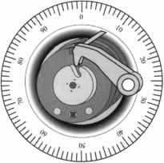

Mosier uuestion

By Don Dennis

1. / ***have taken a detent out of another***

***302 lock and laid it inside of a lock body  
beside a detent, which is still in place.***

***A) Mosier MR-302 without drive wheel and dial.***

141 ***Keynotes***

May 2000

half of the drive wheel continued to rotate. The split drive wheel would meet its limits snapping back together to its normal rotation pattern. The drive wheel is held together by a post and C clip arrangement. Removing the C clip will allow the wheel to separate exposing the spring. In a neglected unit, sluggish snapping of the wheel can result. This snapping of the wheel takes place between 90 and 10 on the outer dial of the safe unit. However, cleaning and replacing the lubrication will bring the wheel back to top performance. The lock’s back cover is very unique. It holds the tumbler wheel nest as well as a detent that depresses the lock’s relocker when the cover is in place. Beside the brass detent is a slot or gate where the fence screw will rest and move. The only way to remove the back cover is to have the lock’s locking bolt extended in the locking position. This will allow the trapped fence screw to move out of the slot and into the open gate area, thereby releasing the cover. Therefore, when changing the combination, the door must be locked open with the bolts extended, before you can remove the 302’s back cover.

I have found more of the MR-302 model in the field than the MRK-302 model. I do not know if there were more of one produced than the other, or whether there are just more MR-302’s in my part of the country. I learned about the differences in the Zamak-Delrin tumblers when an office worker tipped over my working surface while I was changing the combination. It all fell to the floor and resulted in a scrambled mess, causing panic to rush through me. This had never happened before and all I could do was to calmly collect the pieces assuring her that no damage was done. In secret, I was a total wreck, but I was right. No damage was done.

The Zamak wheel centers are all the same. That is

The Mosier 302 has been the dominant combination lock of the Mosier product line since it was introduced in 1963. Up until the middle of the 1990’s when production ceased, if you were called upon to service a Mosier safe container, the odds were in your favor that the lock would be a 302. Now, the question is clear that the safe technician must find a solution for lock replacement options as well as for ways to make the 302’s, that proliferate the field, last as long as is reasonably possible.

Patented on January 15, 1963, the Mosier 302 series has either a key-change or hand-change, manipulation- resistant combination lock. The most popular of this series were the MR-302 and the MRK-302. The MR was Mosler’s hand-change model, which is featured in this article, while the MRK was their key-change model. Both models had three tumblers either made entirely of brass and Delrin or of Zamak and Delrin. The Zamak and Delrin wheels were the hand-change version.

One of Anthony J. Potzick’s efforts, a shutter driver invention, made the 302 manipulation-resistant. It was a combination of a drive wheel that ‘snapped’ while passing through the drop-in point of the fence and a spring-loaded detent located in the lock body that rested against the drive wheel. As the drive wheel rotated, by turning the outer safe dial, it came into contact with the spring-loaded detent. The detent would fall into a notch on the bottom half of the drive wheel holding onto the bottom half of the wheel momentarily. As the dial continued to turn, the upper

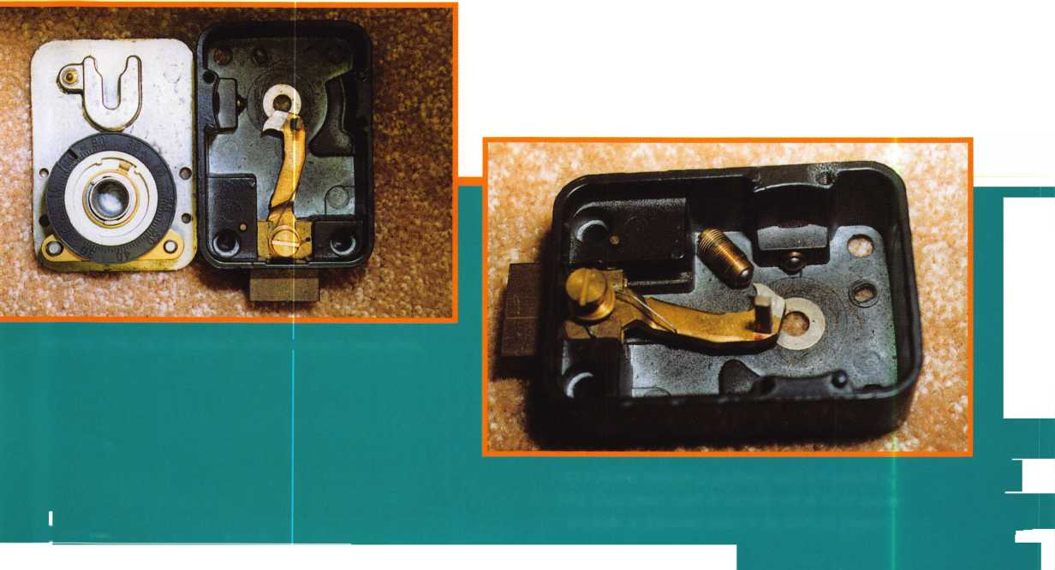

1. ***These are several parts of a 302 and their condition as talked about in the article.***

May 2000

1. ***This is three 302 drive wheels. The front and back of what a drive wheel looks like are on the bottom of the photo while the top is a wheel that has had the C clip removed and separated into two halves, exposing the return spring on the black half.***

***Keynotes***

with the exception of the first wheel lacking a drive pin on its bottom side since it rests on the phosphorous bronze shim washers against the back cover. Otherwise, all of the notches and marks are the same. Likewise, all of the flies are also identical. The Delrin outer tumbler rings all have teeth that mesh into teeth of the Zamak centers, aligning the mark on the Zamak center with a number that is molded in the Delrin ring. The rings are numbered with 100 numbers that relate to the numbers on the dial; and, the number selected is the number that will translate to the outer dial as the combination number for that tumbler wheel. Also, molded into the Delrin ring, on the same side as the combination numbers, are the numbers 1, 2, or 3 depending on which tumbler you are working. This allows you to take the entire nest, jumble everything up, and yet still sort it all out. Between the first and second tumbler is a brass spacer that holds itself in place over two posts that are molded into the back cover plate. There is also a spacer between the second and third tumbler that is also held by the posts.

You can tell when a lock has been neglected and is in need of light lubrication. There will be a buildup of brass on the Zamak surface. Please note the lubrication is always a very light coating. Anything more may hold the tumblers back from proper performance. It is a case where too little lubrication exerts extra wear on the surfaces and too much will make them stick or even drag other tumblers out of sync. What is too little or too much? If you can feel it, it is enough. If you can see it, it is too much.

There is one other thing that I want to say about the 302, and it deals with the spline key. If you are familiar with removing spline keys from the mating of drive wheels and spindles, then you are aware of some of the difficulties encountered. While the following is not foolproof in not breaking apart the 302s spline key, it is one method. If you look at the center of the spline

key, you will see that it is drilled and threaded. Taking one of the screws that holds on the back cover and inserting it into this threaded hole, the spline key will be removed with just a few turns of the screw. No prying or pulling is needed. This will always work unless one of the feet of the spline key has been fractured or has some undue metal fatigue. (This will not work on later models of the 302, because they changed the design of the spline key to a flat, stamped steel, horseshoe shape.)

The spline key is not intended to be that tight in the first place. The post that contains the tumbler nest is hollow and houses a spring and Delrin cap. This cap places pressure against the spline key making certain that the key does not back away from the drive wheel. By design, this feature tells us that the spline key is not intended to be overly tight. Therefore, if you are servicing the 302, do not think it is necessary to create more tension in the fitting of the feet as they enter the mating of the drive wheel and the spindle. In other words, you do not need to press or bend the feet towards one another. There needs to be only enough tension laterally to keep the dial and drive wheel from having a ‘wobble’ as one drives the other. A ‘wobble’ would result in an ever changing combination, meaning that the numbers may never be the same from one dialing to the next. If you can hold the drive wheel with one hand and slightly move the dial, without having the drive wheel move, then you have the ‘wobble.’ To fix this, the feet need to have a ‘slight’ bend in one of them. Do not make the bend by clamp­ing the end cap of the spline key and

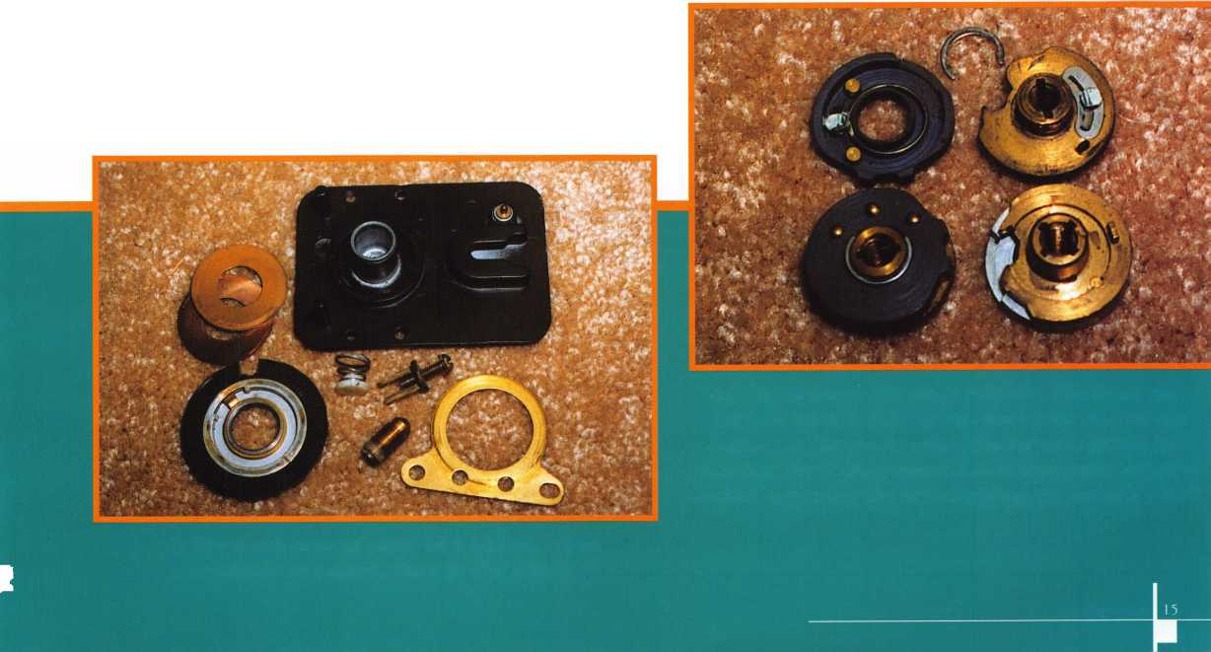

***F) This is the llco 673M.***

1. ***The foot patterns are the same on the 302 (left) and the llco 673M (right).***

It's True

Marrcty has developed the first  
screwless door loop.

Aluminum ma­terial means true anodizing.

No off color powder coat­ing or painting

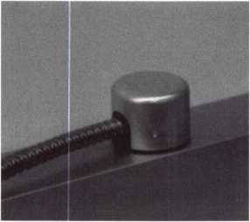

Standard 18”  
length. Can be  
ordered in cus-  
tom lengths

Plastic base stops  
shorts and pro-  
tects wires

Screwless base and cap means you drill two 1/2 inch  
diameter holes, pop the base into the hole, wire your  
system and snap on your covers. Simple as 1, 2, 3.

**Here’s the best part we are giving away a**

FREE SAMPLE TO THE FIRST 1 OO CALLERS WHO MEN-  
TION THIS ADD. A $14.40 WHOLESALE PRICE VALUE.

CALL TODAY, IT’S FREE!!

1-800-500-1449

Marray *enterprises, inc.*

At **Marray,** we’re not **just** modifiers, we’re Master Hardware Modifiers™  
**1128 Walsh Ave., Santa Clara, CA 95050. [www.marray.com](http://www.marray.com)**

trying to bend the tips. This will create the cracking or metal fatigue that I mentioned earlier. Place your pliers between the end cap and the tips of the feet. Then bend the foot slightly at the tips, so slightly, that the bend is almost unnoticed. Too much bend and you will break off a foot the next time you do a service.

To accomplish this task, you can make a special tool from a pair of wire cutters. Cut down the outer curves of the jaws on a grinding wheel to the point that a jaw will fit easily between the feet of the spline key. Squeeze the grips gently until you crimp the foot. This will crimp the leg of the foot just enough to solve the ‘wobble’ problem and yet, not make the foot so tight that the next service will create a breakage. I do not know if this is condoned in most circles of servicing, but it has served me well for more than 25 years on not only Mosler, but also on spline keys produced by other manufacturers. Remember that the 302 is no longer with us, nor are their parts. Replacement of the spline key with a new one is not a possible solution. If making a tool is not your desire, then there is one on the market that will do the job. It is a cutter that is carried by Snap On Tool. Find one of their

May 2000

Keynotes

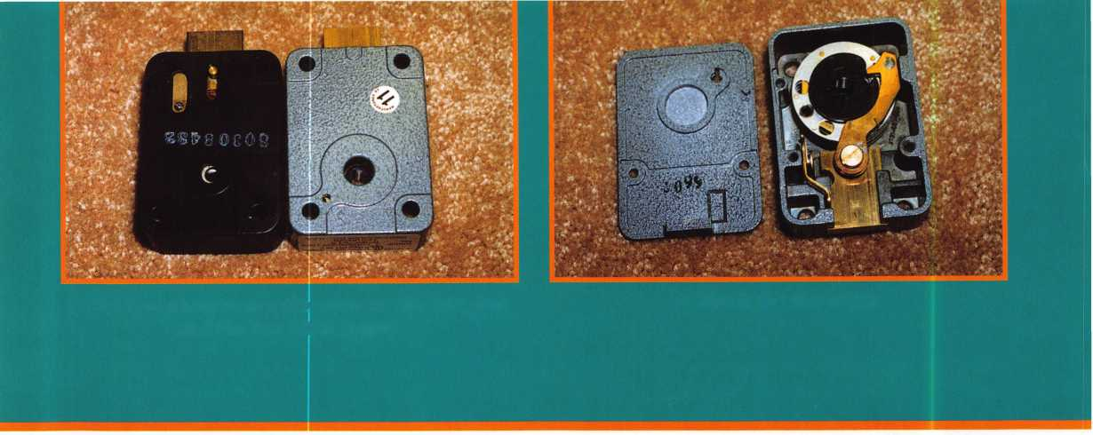

***C) La Card makes the dial ring, dial cover H) This is the kit that makes up the rest of the***

***and a dial which will accept a 1/4" spindle conversion. The drive wheel has the 1/4***" ***hole,***

***manufactured by Lockmasters. The bolts will meet the needs presented by Mosler***

***and if you want to meet conditions for a key locking  
dial then the parts are also a part of the kit.***

; . . . ,■

trucks and ask for an E706B cutter. It has an offset jaw that will easily reach between the feet of the spline key to do the job.

When we look at the replacement of a 302, we encounter problems. The problem is not in the foot pattern of the lock case as it is mounted to the safe.

The foot pattern is the same as with an S&G 6730. The problems are found in the dial spindle and, in some cases, the bolt of replacement locks. Many times the spindle hole that is drilled into the safe door will not accept the spindle of the S&G 6730. The hole is smaller to accommodate the 1/4” spindle of the 302 dial. Don’t even think about trying to increase the hole’s size. You will have Mosler’s infamous Relsom hardplate to deal with. That is not even a fun thought. What is the answer?

Lockmasters in Nicholasville, Kentucky has a solution. They produce a product called a MOS302PKG. No, the name is not the clever part! They have made a package that contains an Ilco modified lock (6730 modified to a 673M), which is combined with a dial and spindle (1/4” x 28), a replacement drive wheel, and several different sized lock brass bolts. The extra brass lock bolts are the standard 1 1/4” long bolt with threaded screw holes in its end and a 3” bolt. You simply pick the lock bolt that will work for your application and replace the one that comes with the Ilco lock. Take the drive wheel that comes with the Ilco lock and replace it with the modified wheel that will fit the 1/4” spindle. The dial is made for Lockmasters by La Gard. Lockmasters makes their own spindle which is pressed into the dial. There it is! By taking the Ilco lock, La Gard dial, a bolt variety, and making their own drive wheel and special steel spindle, we have a solution for a 302 replacement. I have used this lock kit on a Mosler round door money chest and it made a perfect solution to what would have been a mighty big problem. The lock with the modified parts will run you about $125. You can contact Lockmasters and place an order at the following: Lockmasters, Inc.,

5085 Danville Road, Nicholasville, KY 40356-9531, 1-606-885-6041 or 1-800-654-0637, FAX 1-606-885-7093.

(Note: The author would like to thank Barbara Cray craft, The Harry Miller Collection, and the folks at Lockmasters for their help with this article.)

Editors Note: Replacing A MR302 with the kit indicated in this article is mechanically possible.

However, the end user should be cautioned that the replacement lock will not be a Group 1 Manipulation Resistant Lock.

SAFE CORPORATION

Manufacturers of Quality

Depository Safes and Chests

Distributing from Warehouses in

LOS ANGELES, CA • CHICAGO, IL • GLASSBORO, NJ

A&B is now a stocking distributor

for Mutual Safes featuring

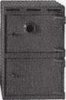

AB-43035 AB-9 FL WS 10-2

Choose from over 75 models in stock  
We ship your order within

**24** hours

See us at [www.a-bsafecorp.com](http://www.a-bsafecorp.com)

1-800-253-1267 Fax 856-863-1208

CALL FOR YOUR CATALOG TODAY

May 2000

Keynotes L

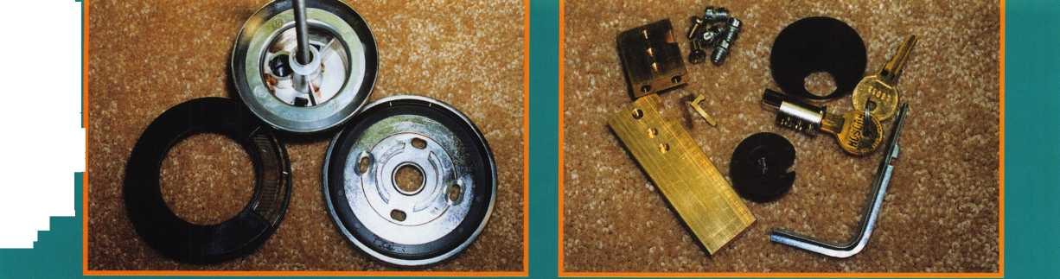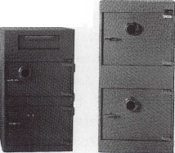

luccess

By Claire L. Cohen, CML

hardware design and  
scheduling of a  
masterkey system.

He began to specify  
hardware brands and  
types to be used. He  
now signed off on  
construction documents.  
Looking at the hardware  
portions of new  
construction contracts  
was now part of his  
job. Now he was  
working on the bidding  
process too!

In the past our  
locksmith would install  
the hardware; now he  
would say, 'have my  
shop install it'.

The contractors are  
now working with

him. They rely on his expertise to coordinate work to  
insure that it is correct. Working with manufacturer  
representatives, they assist in inspecting work to insure  
it is to specification. Monitoring warranties comes under  
his area of involvement. If replacement is needed, it is  
his responsibility to check warranty information and  
coordinate with manufacturers to get parts which have  
not met their guarantee, replaced — at no charge. This is a  
major benefit to his organization, as he is providing the  
expertise to insure that this is done.

All through this process, top management is aware that they can rely on our locksmith. He keeps communication lines open to insure that management knows the status of all projects.

Moving up in the organization, our locksmith is now a management 'assistant'. As the assistant, he begins to get other related types of projects, such as replacing doors.

Our locksmith's manager is now promoted and guess who is logical choice to take his place??? Our former security officer finds himself in charge of the entire complex: The Locksmith Shop, Technical Security Systems, CCTV, Access Control and Life/Safety Area.

While attempting to grow and improve your skill level, take an active part in the management areas. Insure that you attend more trade shows, more management training, some facility management training, project management courses, loss prevention exhibits, and security training. Computer skills training is extremely important, also. Your management should be guiding you and providing input as to seminars and classes that are available.

**GROWTH**

In the growth  
stage, he conveyed to  
management that he  
would like to become  
more involved with the  
entire project from  
start to finish. “Get  
me involved!!!”

Our locksmith found at this point that he was doing  
less and less installation, and more and more involvement  
with the project planning and design. He had moved up  
into a new environment. The management was beginning  
to groom him to go forward!

He was now asked to attend project meetings where  
discussions included hardware issues, budgetary  
considerations, etc. Over time, he was considered a  
"Consultant" or a "Security Specialist". Finding himself  
moving from lock installer to Consultant, he was gaining  
respect for the technical knowledge he had accumulated  
in the industry. His title changed. Daily attire changed  
from a uniform to a suit and tie and so had his salary!

He had a more flexible time schedule. Peers now  
recognized him as an expert in the field of security.

He was no longer part of the Building Engineer or  
Maintenance Staff. He was considered part of "our team"  
and accepted as part of management.

He had proven to his supervisors that he was a team  
player and could be counted on and defend his position.

His manager continued to feel more confident working  
with him and felt he had more freedom to do other  
things, leaving our locksmith professional in charge of the  
tasks he formerly performed. Supervisors began to say,

"you go there and handle this!" He was building a 'trust  
relationship'. Supervisors knew our locksmith's role had  
now changed dramatically.

Our locksmith became more involved in the planning of  
projects, working directly with architectural firms, on the

In last month’s  
article (part 1), you  
followed the career  
path of a security  
professional through  
two stages outlined  
for his success. This  
month, he will  
continue with the  
Growth stage and finish  
with Today/Future.

Keynotes

May 2000



Aim high! Your goal is to convey to management that you want to do more. Working together with your management, you are soon growing into the area of doing what your boss is doing.

TODAY S. THE FUTURE

Our security professional now looks at how your former boss did the job. His goal: to do it better. He manages all projects from A to Z — the whole complex. He manages all security-related contracts.

He continues and expands upon the relationship with outside contractors and manufacturers, partnering with them. He receives aid from his partners to test equipment and aid in educating him on new products.

He is interested in further growth, further knowledge of the industry he embraces. He looks forward, never relying on the past performance.

The journey our locksmith has traveled has not ended. He is still learning, still striving to do better. He is a valued member of the security industry, with hopes to go beyond. He offers the following final advice.

Maintain good relationships with all managers, manufacturers, suppliers, factory representatives, etc. You never know when you will need their help. Network with others. Form alliances with others in your field. Help them and they will help you!

* Keep your options open.
* Take project management courses. Learn how the pros do it! Know the cost of doing business.
* “When you drive a car, don’t look through the rear view mirror. Look through the windshield. What comes ahead - that's the future.”

Author’s note: Our thanks to an inspiration in locksmithing — Shafic Bhimji, Security Specialist, The World Bank,

Washington, D. C. for sharing so much with us.

**BE A PART OF 1.800 LOCKSMITH!  
USE THIS NUMBER IN YOUR CITY  
& OWN THE MARKET!**

We are looking for qualified locksmiths who want to expand their business

and develop themselves into one of the largest locksmith operations

in their city. You will be authorized to use our logo and name

and we will advertise for you on radio and television.

Insterested locksmiths will be able to “secure”

as large or as small a territory as they

desire. Territories will be based

on zip codes.

I



**[www.](http://www.1800locksmith.net)**[1800](http://www.1800locksmith.net)**[locksmith.net](http://www.1800locksmith.net)**

**Call today for more information or to sign up!**

May 2000

Keynotes



by Sal Dulcamara, CML

While there are many brands of containers (safes), there are much fewer safe lock makers. Sargent and Greenleaf (S&G) is probably the most common mechanical safe combination lock found, followed by La Gard. If you brought just two of the most common change keys with you, more times than not, you would have the proper tool for the job. There are a number of less common change keys that you would tend to need on a less regular basis.

Keedex makes a number of clever and useful products, which include locksmith tools for various specialized tasks. Among some of the safe related products, Keedex makes two sets of change keys. On top, in Photo 1, is the K-18 Change Key Set. Below it is the K-GSA GSA Type Change Key Set. Opened up in Photo 2, the K-18 set contains the following twelve change keys: Mosler-35-4 Wheel (K-18-1), Mosler-302-3 Wheel (K-18-2), S&G Amsec 3 Wheel (K-18-3), S&G-6720-3 Wheel (K-18-4), Diebold-180-3 Wheel (K-18-5), Diebold-177-4 Wheel (K-18-6), S&G Padlock-3 Wheel (K-18-7), S&G-4163 (K-18-8), La Gard-lR-3 Wheel (K-18-9), La Gard 3 Wheel (K-18-10), La Gard 4 Wheel (K-18-11) and La Gard-Amsec-3 Wheel (K-18-12). They fold out “knife style” like many of the popular Allen Wrench sets which have a number of commonly used sizes, all within the same tool.

Its compact and convenient to keep in a tool case, for ready access. It’s also handy in situations where a customer may ask to have a safe combination changed while you are there to rekey the locks. In that circumstance, you may not have planned on changing a combination and forgot to bring the change keys needed. A similar situation may have you changing a combination, only to find out that you don’t carry an individual change key for the safe lock in question. If it happens to be one in the set, however, you would have had the tool with you.

Photo 3 shows one of the change keys in use on a mounted cutaway lock. It is a 3 wheel La Gard lock, with the appropriate La Gard style change key inserted. It is a bit more awkward to use than a standard individual change key because the standard key is lighter and doesn’t have many other tools attached. Even if the choice is a bit more awkward, faced with not having an appropriate change key to do the job, awkward becomes a good option.

Photo 4 shows the K-GSA set with the change keys pulled out for display. Most of the parts are change keys for GSA rated containers, although there are a few general servicing tool attachments. Also included are a Phillips and slotted head screwdriver tip and a couple of specific Allen Wrenches. If you always carry both sets of tools with you regularly, you’ll rarely find yourself without the right tool for the job, when resetting combinations.

Keedex products are widely distributed at locksmith supply companies. If you can’t find a supplier that stocks the change keys or other Keedex products, contact: Keedex, Inc., 12931 Shackelford Lane, Garden Grove, CA 92841-5108. Phone: 714/636-5657. FAX: 714/636-5680. E-mail: [safe@keedex.com](mailto:safe@keedex.com). [www.keedex](http://www.keedex) com.

Photo 3

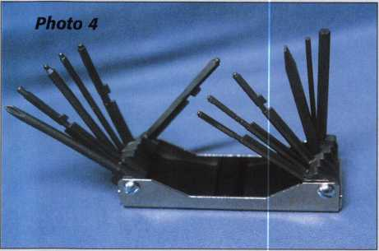

Keynotes

May 2000

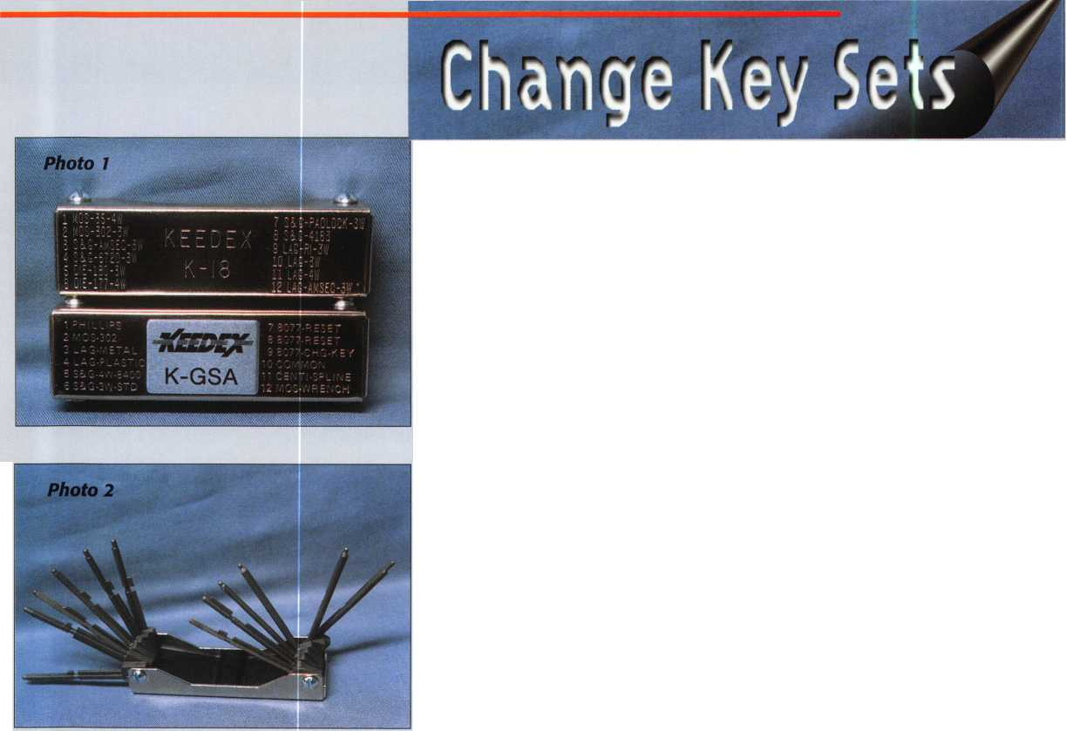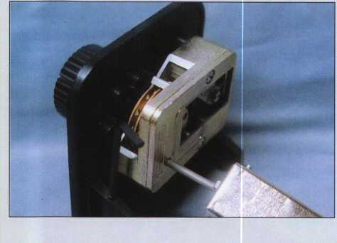

VISA

XL ATM .DIBIT

Is CARD

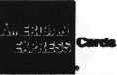

Diners Club International*

Accept Credit Cards  
and Increase Sales and Profits  
by 30% - 50%

CVaTEVJ^-

Through Association Benefits

These Concerns Are Eliminated

There are three reasons why people don’t accept credit cards:

1. Too expensive.
2. The paperwork hassle.
3. Inability to qualify.

Here’s how it works:

* Simply swipe or enter the credit card #.
* Enter amount of sale. ]\o Hassle - Ea\V Qualifying
* Approval within seconds.
* Funds wired electronically into your local checking account within 48 hours.

Because of your association membership, nearly 100% of all retail and home based applicants

will be approved even with past credit problems.

Currently Processing Merchants Please Read

Monthly Lease To Own Set-Up Options

Special Low Discount Rate and Transaction Fee: 1.59% + 20$

Plus Monthly Statement!Customer Service Fee: $10

Package A: $29.95 Terminal

Package B: $39.95 Terminal & Printer In One

Deluxe Package C: $49.95 Portable Terminal/Printer/Pin Pad  
Debit acess fee Ability to Accept Visa/MC “Check Cards”

$ 10/mo. & AXM c^ds at a FLAT 25$

Totally Eliminating the 1.59 % Rate  
(All lease terms 48 months • Monthly minimum **$25)**

J I authorize Universal’s sales office to print and deposit a check  
in the amount of $49 (normally $125) for my application fee which

covers initial materials, application processing, equipment warranty,

shipping & handling, programming, installation and training.

* Fill out a check, tape here above mini form and then fax.

Fax Express Mini Form Now To 1 -800-439-7773

Cur%ntty5$ ***** For **M**

* fccS?

rPer(

'and

“‘“ac&oaf

iaod*lred

<*loS**®*

minj-i

fora bei,

tow.)

Feesf

Company Name. Contact Name _

Address. City

State.

Zip.

Phone

Best Time

Signature

New Account Set-up Options (Cheek)

n

Package A 1—1 PackageB □ ^

Deluxe Package C I—I

Free Pin Pad Program For Currently Processing Merchants □

A subsidiary of Universal Savings Bank, FA.

Marketing Office ***1****-****800****-****836-4295***

Universal Payment Processing Provides 24 Hour Live Customer Service.

May 2000

Keynotes



When is a

By Brian Costley, CML, CMS

The week between Christmas and the New Year is the one I dread most. That’s when all those unblemished, beautifully appointed gun safes and cabinets that were delivered just in time for Christmas get their lock combinations changed for the first time. Perhaps “altered” is a more descriptive verb. The Sargent & Greenleaf customer service phones ring loudly and continuously, and the person on the other end of the line invariably starts the conversation with, “I followed your directions exactly, but...”

Combination changing is the port of entry that beckons most locksmiths into the world of safes. Reading the lock manufacturer’s instruc­tions, the process seems very simple and straight­forward. As with most things in our industry, however, there is a lot more to combination changing than meets the eye. It is fraught with small, malicious demons just waiting to bite the unwary in the fleshiest part of the anatomy (the part that rhymes with “cut”).

The purpose of this article is to address proper combination changing techniques and discuss what can be done when things go wrong.

I am a firm believer in the concept that a conscientious technician is obligated to fully service a mechanical combination lock when called upon to perform a combo change. However, servicing is a subject for another time and much more space. We’ll stick to combination changing and combination changing “oops” for now.

As with any other task, you need to be prepared. That means having the right tool(s) and adequate knowledge for the job at hand. The tool part is simple. Obtain the original manufacturer’s change key, and make sure it’s in good condition. A typical change key will perform thousands upon thousands of combination changes with virtually no evidence of wear. It does, however, take a beating when thrown in amongst your other tools and then subjected to the vibrations inherent in transporting the whole jangling mess to and from job sites. You don’t throw your

■

Simple Combin

precision dial calipers into the toolbox alongside files and screwdrivers, do you? Show your safe lock change keys a little of the same respect.

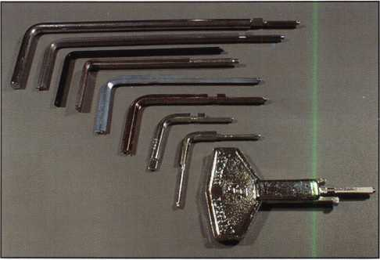

Multiple individual change keys, covering a multitude of combination locks from three prominent manufacturers.

Generic change key sets from sources other than the original lock maker may or may not be adequate for the task. As far as the lock manu­facturer is concerned, it’s a use-at-your-own-risk scenario. The lock maker has no control over the dimensions, material, or consistency of another company’s products.The generic sets are quite useful, however, when the original is obsolete or very difficult to acquire.

Then there’s the intellectual tool box. Armed only with a change key and the printed instructions that came with the lock, you’re no better

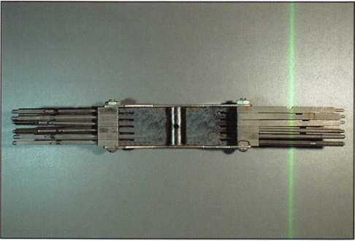

This generic change key set contains some hard-to-find keys for locks you will encounter infrequently.

I (eynotes

May 2000

ition Change NOT Simple

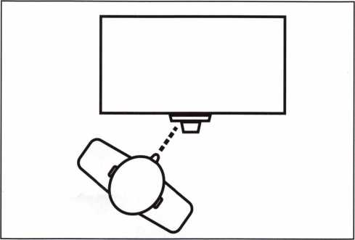

Viewing the dial and ring from the side (above) is very likely to lead to inaccuracies in combination setting. Always look at the dial and ring from straight on to achieve the best results in the shortest amount of time.

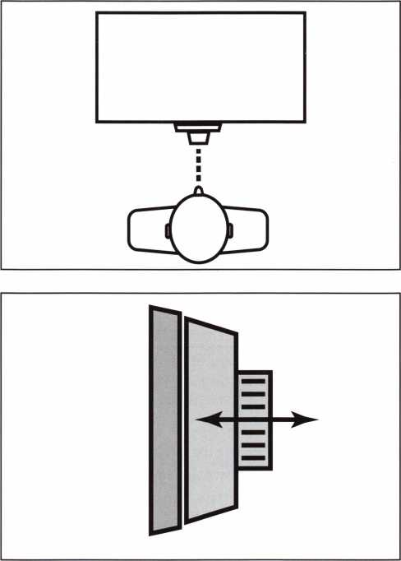

End play (the distance the dial can move in and out of the ring) is typically no more than .040 or .050 inch. A little end play is good. A lot is bad, and should be corrected.

equipped to change a combination than the safe owner. Frightening thought, isn’t it? Just a little knowledge will remedy the situation; knowledge about things like dialing tolerance, the forbidden zone, and wheel pickup. You can also impress your customer by enlightening him or her by explaining the importance of good dialing technique and viewing angle.

Satisfy yourself that the lock is in good working condition. This is where a thorough servicing comes highly recommended. You can count on the fact that whenever a customer insists that you “just change the combination” to avoid a servicing charge, the lock will fail to operate within two weeks of your ministrations. Then you will fall into the “you touched it last so it must be your fault” zone.

It is usually easy to figure out if the customer is requesting a combination change for security reasons or to hopefully correct an operating problem with the lock. Ask him to write the current combination down for you, then watch him open the safe. This is the moment of truth.

If he can’t open it on the first try, it’s time to start asking questions about how many attempts it usually takes to open it and whether this is a relatively new or long term issue. This is also a good time to observe and correct bad dialing habits. Does the customer spin the dial rapidly? Does he view the dial and ring from the side, rather than straight on? Are there any other bad habits that require hand slapping?

Short of a full servicing, you can tell a lot about a lock in a very short time without ever removing the cover. You can try to wiggle the lock case to make sure it’s not loose (and therefore changing its operating combination slightly every time it moves). You can check to ensure that the dial ring is tight against the front of the safe.

Dial end play can be checked by pushing the dial toward the safe door and then pulling it away from the door. The amount of travel should never be more than .050 inch, with a maximum of .025 coming closer to the ideal. Just be sure you are

May 2000

Keynot

not working with one of the Group 1 or 1R style locks that incorporate a dial designed to be pushed or pulled at zero to activate an internal component.

And then there’s the pile of information you can get by just turning the dial. On the majority of locks you run into, the following pieces of information can be gleaned from a few simple dialing procedures:

1. Alignment of the dial ring
2. Number of wheels in the lock
3. Amount of friction in the wheel pack
4. Condition of movable flys
5. Amount of rotation from wheel pickup to wheel pickup
6. Contact points (location of the forbidden zone)

Have you got a combination safe lock mounted on a table-top stand? Want to work on safe locks? Get one; preferably one that is partially cut away to let you to see the components interact during dialing operations.

It’s the best teacher and best friend you can have when it comes to safe work. If you practice the exercises we’re about to undertake on a cutaway lock, you’ll be able to see how the parts move and interact. You will begin to relate what you feel through the dial to what you see happening inside the lock. With a little perseverance, you’ll get to the point where what you feel through the dial will translate into mental images of moving lock parts. This is an invaluable skill in safe lock work, and it’s probably very similar to what you do when you pick a tough key lock.

Our sample lock is a generic, three wheel, Group 2 style, representing the most common type of safe lock we’re likely to encounter. These techniques will also work on four wheel locks and many vault locks.

Starting anywhere, rotate the dial left (counterclockwise), stopping when 50 comes to the opening index the fifth time. Fifty is just an arbitrary reference number. It has no special significance, other than the fact that it is well away from the contact points of properly installed locks. Five is the minimum number of turns

required to get all of the wheels of a four wheel lock moving in the same direction and parked on the same number. If five turns will accomplish this for a four wheel lock, they will also accomplish it for the more common three wheel lock. Also, we could have started the exercise by turning the dial right instead of left. The point is that very little of this procedure is arbitrary, and I don’t want you to get the impression that variation is not allowed. In safe lock diagnostics, there are many ways to skin the proverbial cat. This exercise has to contain some number of

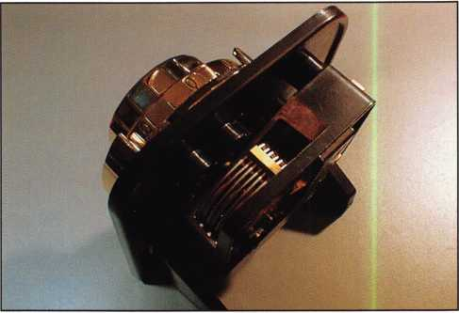

A cut-away lock is the best friend you can have when learning about safes...and you never stop learning.

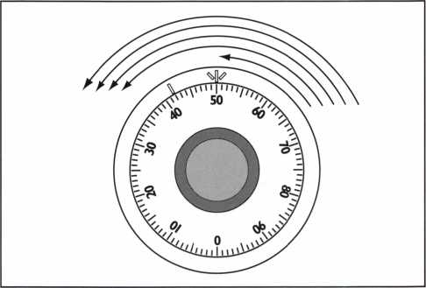

The first step in our process of checking the lock is to “park” all the wheels at the same place. One of the many ways we can do this is to dial at least five times left to 50.

turns, some number to stop on, and some dialing direction. I pick what works easiest for me. You are free to imitate the teacher or take your own path. Having said that, let’s get back to the exercise.

We’ve turned the dial at least five times left to 50. In common safeman’s terms, we have parked all wheels left on 50. When you park wheels, it is important to know the number to which

eynotes

May 2000

they have been parked, and which direction (left or right) was used in rotating the dial.

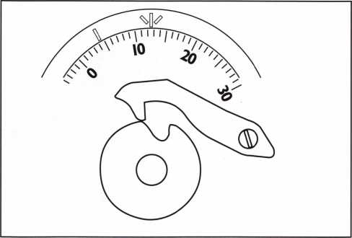

The right contact point is the first one felt when turning the dial right. It is the result of the lever nose striking an edge of the drive cam’s gate.

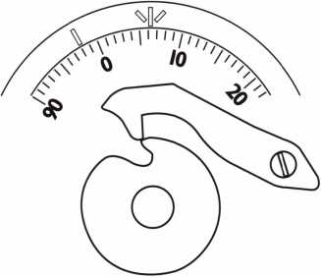

The right contact point is the second one felt when turning the dial right. It too is the result of the lever nose striking an edge of the drive cam’s gate.

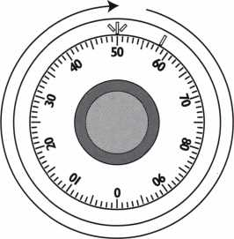

If everything is working correctly, we should pick up one of the lock’s three wheels very near 50 as we turn the dial to the right.

Starting with all wheels parked left on 50, turn the dial right (clockwise). Use no more than two fingers on the dial, and grip it very lightly. This will help you feel what is going on inside the lock. During the first full revolution right, you are moving only the dial, spindle, and drive cam. These three parts are tied together and always move as a single unit. This first revolution to the right provides the best opportunity to detect any binding between the dial and the ring. The ideal is to have virtually no friction between the dial and ring. Dial ring binding is probably a sign of improper dial ring alignment, but it could also be telling us there is something wrong inside the lock. Lock servicing is necessary when dial binding is evident.

As you turn the dial right, descending through the span of numbers running from 20 down to 0, you will probably feel two subtle “bumps.” These are the locks contact points, or points where the lever nose strikes the sides of the drive cam gate. It’s helpful to become familiar with the feel of contact points. They will become critically important as your skills progress into the area of safe lock diagnostics and manipulation. You should be aware that contact points do not always fall between 0 and 20. This is simply the most common area in which to find them.

As you continue turning the dial right, you should feel slight added resistance when you get near 50. That’s because you left all the lock’s wheels parked left on 50, and you now pick up, or begin to move one of the three wheels. You expect the wheel pickup to occur within one or two numbers of where you left it parked (50 in our example). The most likely pickup spot (other than the Blue Lizard Lounge) will be one-half to one number beyond the place where the wheel was parked. In our example, all wheels were parked left on 50. On our first revolution to the right, we will probably experience our initial wheel pickup at about 49 1/2.

If you pick up the wheel about ten numbers less than a full revolution, say at 58, the lock is telling you it has a stuck fly on that wheel. While it is not common to find a stuck fly in what

May 2000

Keynote

appears to be a normally functioning lock, I have seen it happen. It can occur if the fly is stuck when the initial combination is set, and it remains stuck in the same location. If it never moves, the set combination will continue to operate just fine. If, however, the fly moves even slightly, the lock will no longer operate on the set combination. If you discover a stuck fly during your pre-change check, the lock needs immediate service before the door is closed again.

In our exercise, the initial wheel pickup was at 49 1/2, so everything is fine...so far. On our second revolution to the right, we feel another increase in friction as we go past 49. We’ve picked up another wheel very near the place where we left it parked, indicating that life is good and our lock is healthy. What if the increase in friction was felt at about 59? That’s right, it’s indicating a stuck fly on that particular wheel, and that lock servicing is mandatory.

We continue turning the dial to the right, and feel a little more resistance when we reach 48 1/2. Yup, we’ve picked up another wheel close to the place where it was initially parked. So far, so good. If we had felt the wheel pick up at 57 or 58, it would be telling us it has a stuck fly.

On our next revolution to the right, there is a curious absence of any change in the feel of the dial as we pass through the area near 50. What does this mean? Simply that we’ve run out of wheels to identify through our parking-then- dialing process.

Let's review what we've done in the dialing process and what the lock is telling us. We'll take it step by step.

1. Park all wheels left (counterclockwise) on 50.
2. Rotate dial to the right (clockwise)

approximately one revolution

* there are no places where the dial “drags” during rotation
* two contact points are noted when dialing right from 20 to 0
* a wheel picks up at 49 1/2

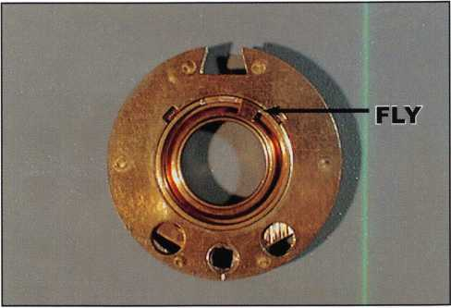

A typical combination lock wheel with its fly resting in the wheel center.

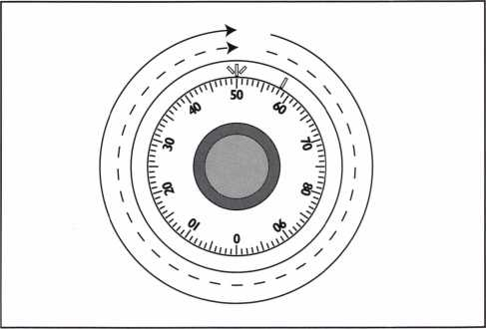

We should pick up another of the lock’s three wheels very near 50 as we make our second revolution to the right.

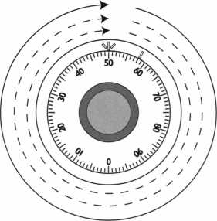

We should pick up yet another of the lock’s three wheels very near 50 as we make our third revolution to the right.

eynotes

May 2000

1. Rotate dial to the right approximately one more revolution

* contact points may be felt again, or may be masked by wheel friction
* another wheel picks up at 49

1. Rotate dial to the right approximately one more revolution

* contact points may be felt again, or may be masked by wheel friction
* another wheel picks up at 48 1/2

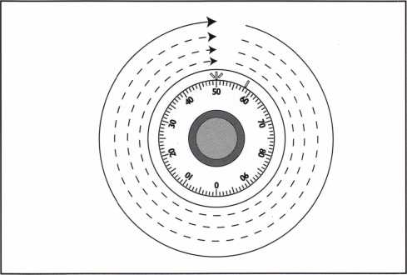

On the fourth revolution to the right, there is no indication that we have picked up another wheel.

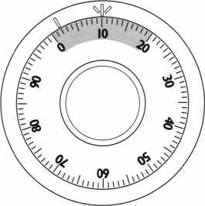

In our sample lock, the forbidden zone is between 0 and 20, and only applies to the last (3rd) number of the combi­nation.

1. Rotate dial to the right approximately one more revolution

* contact points may be felt again, or may be masked by wheel friction
* no wheel pickup is felt

What observations are significant for our purposes?

1. The dial is riding in the ring with no significant binding anywhere in its rotation.
2. The lock is a three wheel design, since we picked up wheels during three dial rotations, but not on the fourth.
3. There are no stuck flys in the lock. All wheels picked up very near the number where we left them parked.

Working slowly and methodically, you can perform the entire dialing process twice in less than a minute. Look at all the information that can be gathered in such a short period of time.

Once you are comfortable that the lock is in acceptable working condition, you can proceed with the actual combination change. Our sample lock is a right-hand constructed, three wheel, drop lever lock. As mentioned earlier, it is representative of the vast majority of locks you will find in use.

Before whipping out the change key, consider the following guidelines for selecting good combination numbers. If the customer specifies a particular combination, make sure his numbers fit the criteria.

1. Do not set the last number of the

combination in the lock’s forbidden zone. This rule does not pertain to the other combination numbers. Remember the contact points we identified earlier? In a standard, Group 2 style, drop lever lock, the forbidden zone extends from five numbers below the left contact point to five numbers above the right contact point. For instance, our sample lock would probably indicate a left contact point at about five, and a right contact point at about twelve. That would have our forbidden zone stretching from zero to seventeen. It would be more than sufficient to refrain from selecting a final combination number in this area. However, lock manufacturers have a

May 2000

Keynote

penchant for rounding off the boundary numbers for their forbidden zones. This leaves us with a forbidden zone on our sample lock of zero to twenty. Now you know how to determine the forbidden zone for most of the locks you will encounter in the field.

Lock makers publish forbidden zones for their locks. To keep from voiding the warranty, always use the manufacturer’s published forbidden zone when you know what it is. When you don’t know what it is, make your determination by identifying the contact points, adding the five number buffer on either end, and then doing some generous rounding.

1. Do not select adjacent combination numbers that are closer than five numbers to each other. For instance, 52-53-39 is not acceptable. Remember when we were counting wheels in our exercise earlier? A wheel does not typically pick up (begin to move) until the drive cam or wheel which drives it rotates slightly more than 360 degrees. It is possible that the second wheel of the lock would not actually move at all if the combination 52-53-39 was used. Separating adjacent combination numbers by at least five numbers will ensure enough wheel movement to maintain proper operation of the lock. Some manufacturer’s instructions call

for a minimum of ten numbers from one combination number to the next, even though five is sufficient. It’s a good idea, however, to always follow the manufacturer’s printed instructions to avoid having a warranty claim automatically thrown out in case of lock failure.

1. Do not use easily guessed numbers. This includes birth dates, phone numbers, street addresses, or similar combinations.

■

systematically dialing combinations that use the “big” marks on the dial.

5. Do not use ascending or descending

number sequences. For instance, 17-74-85 would not be as good a combination as 17-85-74. Mechanically, the lock doesn’t care about this particular guideline. Use of an ascending or descending sequence seems to make it more difficult for the average person to dial a lock open successfully...as if it wasn’t already difficult enough for most “civilians.”

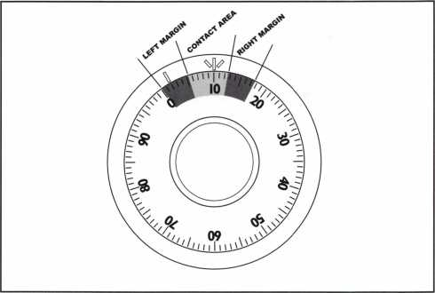

In almost every case, the lock’s forbidden zone is tied directly to the location of the contact points.

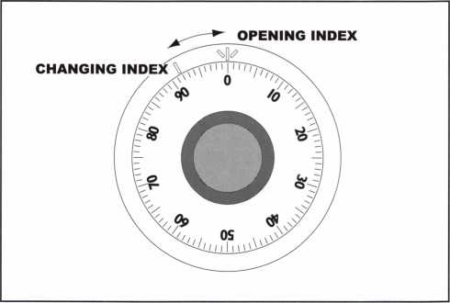

Most locks you will encounter have a space of either 10 or 8.2 numbers between the changing index and the opening index.

1. Do not use numbers that all end in fives or zeroes. For instance, 25-80-50 would not be a desirable combination. Although it would be easy to dial, it would also be easy for someone to guess or determine by



| (eynotes

May 2000

Those are our five guidelines for selecting good combination numbers. The lock only cares about the first two (forbidden zone and adjacent number spacing). The other three are for added security and ease of dialing, important considera­tions for the safe owner.

Even though Eve spent a considerable amount of verbiage to get this far, the actual time consumed in applying all the information covered to this point should be four or five minutes. That even accounts for the time spent watching the end user dial his combination.

The cursory diagnostics and selection of a new combination are complete, so now it’s time to set our carefully selected numbers into the sample three wheel lock. The process is straightforward. There are two index marks on the dial ring. The one at the twelve o’clock position is the opening

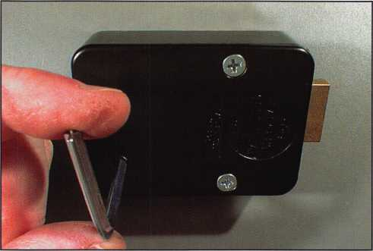

Notice that when the change key is turned in the proper direction, its handle stays within the profile of the lock case.

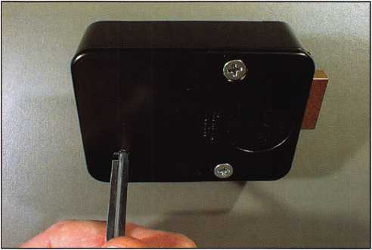

The change key must be fully inserted before it is turned. Otherwise, you could unlock a wheel out of sequence with the others.

index. The other index, most often located at the eleven o’clock position, is the changing index.

The following steps will involve dialing numbers to the changing index. I always find it helpful to either place a piece of opaque tape or my thumb over the opening index during changing operations. That prevents me from losing

concentration and accidentally dialing a number to the opening index.

1. Dial the existing combination to the changing index.

* dial left (counterclockwise) until the first combination number comes to the changing index the fourth time
* dial right (clockwise) until the second combination number comes to the changing index the third time
* dial left until the third combination number comes to the changing index the second time

1. Insert the change key fully into the change key hole in the lock’s cover. The change key’s flag should be inside the lock body. Sometimes it is necessary to wiggle the change key slightly to complete the insertion. Just don’t get heavy-handed. A combination lock will retaliate if you become forceful.
2. Turn the change key to stop. All key change combination locks have change key stops. The stops determine the direction in which you can turn the change key and how far it can turn. Most locks you encounter will require a ninety to one-hundred eighty degree turn counterclockwise to unlock the wheels. A good tip is to remember that change keys with an “L” shape will maintain the handle of the key over the profile of the lock body when the key is turned in the proper direction. This is in case the lock is recessed into the safe door, and the key’s handle would run into an obstruction

if it had to be turned outside of the lock case profile.

1. Dial the new combination to the changing index.

* dial left (counterclockwise) until the first new combination number comes to the changing index the fourth time
* dial right (clockwise) until the second new combination number comes to the changing index the third time

May 2000

Keynotes

-■

* dial left until the third new combination number comes to the changing index the second time
* turn the dial right approximately ten numbers to take the drive pin of the drive cam away from the top wheels fly

1. Turn the change key ninety degrees back to the position it was in when you first inserted it. Pull it straight out of the lock. Some people develop the bad habit of turning and pulling on the change key at the same time. Avoid this mistake. Turn the key, then pull, but never com­bine the two actions.
2. Check the combination you have just set both high and low. Most Group 2 and 2M locks have a dialing tolerance of slightly more than plus and minus one full number. You should check your work by subtracting one number from each of the new combination numbers, then dialing this new trial combination. Then add one to each of the new combination numbers, and see if this trial combination works.

If you can open the lock on the low trial combination, but not on the high one, you have probably set the combination incorrectly. The same is true if you can open the lock on the high trial combination, but not on the low one. Set your new combination into the lock again. Your goal is to give the customer the best chance of opening his or her lock on every first attempt, even though end users tend not to be nearly as precise as you are when you dial a lock. You accomplish this by ensuring that there is equal dialing tolerance on each side of the set number.

An exception to “standard” dialing tolerances is the S&G 6730. It typically will let you dial half a number high and half a number low.

Group 1 And 1R locks also exhibit this tighter tolerance. Adjust your addition and subtraction accordingly. The tighter the dialing tolerance of a lock, the more concerned you need to be about centering the combination within the tolerance.

On rare occasions, I run across a dial ring that has a changing index incorrectly spaced in



May 2000

PLUS AND MINUS 1.25 NUMBERS

I I

I I

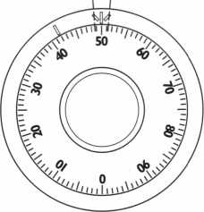

The maximum dialing tolerance allowed by Underwriters Laboratories for Group 2 and Group 2M Listed locks is plus and minus 1.25 dial numbers.

PLUS AND MINUS 1 NUMBER

I I

I I

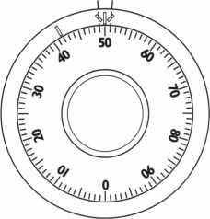

The maximum dialing tolerance allowed by Underwriters Laboratories for Group 1 and Group 1 R Listed locks is plus and minus 1 dial number.The theoretical maximum dialing tolerance for the S&G 6730 is plus and minus 9/10 of a number. In actuality, it ends up being about plus and minus 1/2 number.

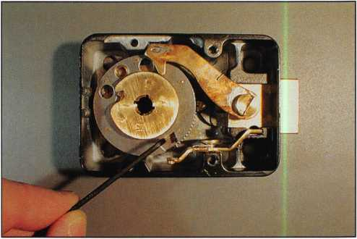

Use something other than the change key to manually rotate the top wheel, searching for the gate in the wheel underneath it.

relation to the opening index. The distance between the two is critical. In locks made by S&G, LaGard, and Ilco, this distance is just over twenty-nine degrees, or about 8.2 dial numbers. Locks manufactured by Mosler required the space to be equal to ten dial numbers. If you suspect

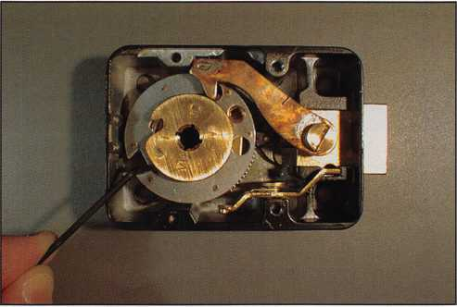

When you have all three wheel gates lined up, you can move them all at once, using your probe.

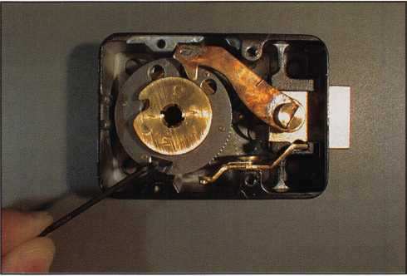

When the top two wheel gates are aligned, rotate them together, searching for the gate in the bottom wheel.

that combination changing headaches may be caused by this rare condition, place zero directly under the changing index, and read whatever number falls under the opening index. This should quickly tell you whether or not the prob­lem is right under your nose. If it is an index spacing issue, temporarily place a piece of mask­ing tape over the changing index so you can mark your own index at the proper location. See if your next attempt at setting the combination doesn’t go much smoother.

Suppose you check a newly set combination, and it simply does not work? It doesn’t work high, low, on the set numbers, or any variation you can think of. The easiest and most straight­forward thing to do is take the cover off the lock

and line up the wheels by hand. The goal is to get the change key cams in each wheel lined up with the change key hole in the lock cover. When you do this, do NOT use the change key to rotate the wheels. In fact, put the change key in your pocket and pick up something like a small screw driver or thin metal rod. Try to avoid any tool that could conceivably rotate the change key cams in the wheels. Accidental unlocking of wheels is a scenario I associate with end users who are unfortunate enough to have been shipped change keys with their safes. They take the cover off the lock and try to move the wheels with the working end of the change key. Don’t imitate the customer; use something other than a change key to move wheels by hand.

Here’s a process that works with the majority of drop lever, key changeable combination locks. To achieve very close alignment of the wheels at the changing location, use your probe in the wheel gates to first line up all the gates at the same location. You should be able to look straight through the lined up wheel gates and see the bottom of the lock case or the torque adjuster through them. Sometimes this is trickier than it sounds. If you have a lock that ends up with the same (or nearly the same) number set on two adjacent wheels, the gates can refuse to line up exactly. They’ll get tantalizingly close, but just won’t allow a perfect alignment. When this happens, the topmost wheel of the pair has to be rotated back in the opposite direction to approach the next wheel’s gate from the other side. In simpler terms, when you can’t get two wheel gates to line up exactly, rotate the topmost wheel in the opposite direction.

Once you have all wheels lined up, place your probe in the aligned wheel gates and rotate all

MasterLink Security Products

ROGER ALEXANDER-TUTTLE, ALOA#5580  
“...understanding the needs of locksmiths...”

Mortise/Rim/Knob Cylinders • Storefront Door Hardware  
Cabinet Locks • Chain • Key Blanks • Padlocks • Pins ...and more

Local: (954) 730.9669 • Toll Free: (877) 347.9669  
Fax: (954) 486.0575

e-mail: [masterlink@mindspring.com](mailto:masterlink@mindspring.com)

3863 NW 19th Street Lauderdale Lakes, FL 33311

May 2000

Keynote

wheels together counterclockwise until your probe is stopped by coming up against the hook in the lever nose. Take your probe out of the wheel gates, and carefully re-attach the lock cover. Your change key should now slide easily through the cover and wheels, until the key’s flag disappears into the cover. Turn the key and pro­ceed with the combination change.

The changing process can be broken down into four basic parts:

1. Determine the condition of the lock
2. Select new combination numbers by following standard guidelines
3. Set the new combination
4. Check the new combination low and high to make sure it is centered

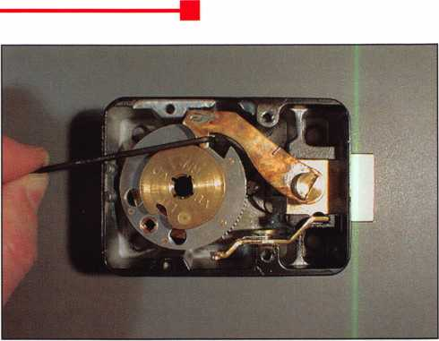

Move all wheels together in a counterclockwise direction, until your probe is stopped by contacting the backside of the lever nose. Remove your probe, install the cover (being careful not to move any wheels), then insert the change key.

They certainly account for a significant amount of my phone time every day.

The first and last items are the ones most often ignored, and they may be the most important.

The question remains—When is a simple combination change NOT simple? The answer, of course, is—When it’s done right.



tim Ktexfc© iocksnuths &ss®ci<rti©&  
ZfltOsQ Armal C@nventi©& S Claaaea  
**June /7-T4 IMsQ**



U

P.0. Box 30956, Albuquerque, NM 87190-0956 (505) 247-9413 (505) 281-6777

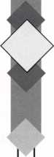

Classes in Professional Bypass Techniques, Combination Lock  
Servicing & Troubleshooting, Basic Automotive Lock Servicing,  
Fundamental Locksmithing, Basic Safe Penetration and BWD  
Automotive Update are conducted by ALOA Continuous Education (ACE),  
instructors. Seminars will be held both Wednesday and Thursday nights. New for  
Friday night is a Gala Event that includes dinner and gaming at the Isleta Palace.  
Once again the trade show will be combined with a reception hosted by NMLA and  
the exhibitors. The 7th Annual Charity Golf Tournament will be held on  
Thursday at the Los Altos Golf Course. The Awards Breakfast and Annual  
Membership Meeting will start at 8 a.m. Sunday morning and will be  
followed by the PRP and STPRP.



The Ramada Mountainview Hotel is located at 25 Hotel Circle NE in Albuquerque.

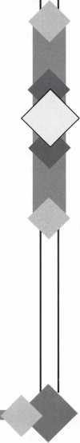

(eynotes

May 2000

YOUR VIEW OF

SAFE TECHNOLOGY

A WHOLE NEW SHAPE

IN ST. LOUIS

**The Ultimate Trip...for Safe Technicians.**

Unlocking impenetrable monoliths is no mystery to you—you've been doing that your entire career. You've also witnessed your industry in a constant state of evolution. To keep up with "what's out there" attend SAFETECH 2001 in St. Louis. You'll appreciate the loca­tion—in one of America's most modernized cities, and the opportunity to explore the mod­ernization of your industry. For more information call 214.827.7233, or email [convtion@anet-dfw.com](mailto:convtion@anet-dfw.com). SAFETECH 2001—Shaping the future.

SAFETECH

**2001**

A SAFE ODYSSEY

ST. LOUIS, MO MAY 1-6



Legislative Update

THE MORE THINGS STAY THE SAME....

by Tim McMullen, Government Affairs Manager

Last week, I was researching the chartering of one of our first chapters, and looking through old editions of Keynotes magazine. The year was 1985. I was flipping through the pages, when my eye caught a Presidential Pennings by Stan Haney titled, “Is licensing ahead for you?” Fifteen years ago, ALOA talked about licensing. We still talk about it today (and in some states have actually done something about it). As I looked further into the Legislative Bulletins each month, I was struck by the issues that were important then, and how they are still important today. In 1985 bills were introduced in Delaware, North Carolina, Oregon, Rhode Island and Texas for the licensing and regulation of locksmiths. States dealing with the licensing and regulation of alarm and/or security companies included Arkansas, California, Hawaii, Indiana, Minnesota, Mississippi, Missouri, Montana, New Jersey, New York,

Oklahoma, Oregon, Pennsylvania, South Carolina and Texas. Pennsylvania was wrestling with a bill on the duplication of keys. As still is the case today, bills for income tax credits for security devices were introduced in the New York Legislature as well as Massachusetts and the U.S. Congress.

In my three years as Government Affairs Manager for ALOA, I have seen legislative activity in almost all of these states. As Yogi Berra would say, “It’s deja'vu all over again!”

LEGISLATIVE UPDATE

All bills that saw movement between 03/09/00 and 04/07/00

ALABAMA S91

SUMMARY: Relates the Alabama Sunset Law; continues the existence and functioning of the Alabama Electronic Security Board of Licensure with

A Keynotes May 2000

certain modifications; clarifies the exemption of any person or business entity that only sells alarm systems at the premises of a customer, but does not enter the premises, or install, service, or respond to alarm

system at the premises.

STATUS:

03/08/2000 From HOUSE Committee on BOARDS AND COMMISSIONS: Reported favorably. 03/14/2000 Passed HOUSE.

03/14/2000 *****To GOVERNOR.

03/21/2000 Signed by GOVERNOR.

CONNECTICUT H5849

SUMMARY: Requires the licensing of locksmiths.

STATUS:

03/09/2000 Filed with Legislative Commissioners Office.

03/22/2000 Reported out of Legislative Commis­sioner’s Office.

03/22/2000 Reissued by Legislative Commissioner’s Office with File No. 178.

03/28/2000 To JOINT Committee on

JUDICIARY. 03/31/2000 From JOINT Committee on JUDICIARY: Reported favorably.

04/03/2000 Filed with Legislative Commissioner’s Office.

04/03/2000 Reported out of Legislative Commis­sioner’s Office.

MISSISSIPPI H1038

SUMMARY: Regulates and licenses the

installation and servicing of burglar alarm systems; defines certain terms; creates the Mississippi and Electronic Security Board of Licensure; prescribes its membership and Administration; provides for the powers of the Board; requires licensing; requires fees; provides requirements for licensee; provides exemptions; provides penalties for violations of this act; provides for uniformity; creates a special fund. NOTE H439 and S2718 are similar to this bill,

but not moving forward.

STATUS:

03/09/2000 Committee substitute adopted on HOUSE floor.

03/09/2000 Amended on HOUSE floor.

03/09/2000 Failed to pass HOUSE.

03/16/2000 Died on calendar.

TENNESSEE S2926

SUMMARY: Creates Class C misdemeanor offense

of unauthorized duplication of safe deposit box key. STATUS:

03/21/2000 In HOUSE Committee on JUDICIARY: Subcommittee on CRIMINAL PRACTICE recommend passage with amendment.

03/29/2000 Died in committee

If you contribute $14.95-99-95 to the Legislative Action Fund, you automatically become a member of the Legislative Action Network (LAN). The LAN is an important tool in raising the standards of our profession through the legislative process by making sure that locksmiths have the final say in how our industry will be run. As a LAN member, you will receive: ten issues of the Legislative Action Network Update alerting you to important legislation in your state and around the country; networking opportunities with ALOA members who share the belief that legislative involvement is important to the effectiveness of our association; a listing of your state representatives and senators including capital and district addresses, and phone and fax numbers on both hard copy and disk; a comprehensive guide to

lobbying in your state capital, so you can be the “voice of ALOA” to legislators; LAN stationary and envelopes for sending official letters to legislators, lobbying on ALOAs behalf; a lapel pin designating you as a special ALOA LAN member; recognition in Keynotes magazine; an invitation to an exclusive reception at the annual ALOA convention for LAN members.

When you donate $100 or more, you become part of the heart of the legislative program through LAN membership and receive all of the above plus the following: a reserved place of distinction on the special LAN Council that participates in determining ALOAs legislative direction; direct input into the legislative strategic plan that guides all legislative activities; discounts on ALOA bookstore items and a 10 % rebate on all ACE classes; complimentary Legislative Convention merchandise. Make checks payable to the “ALOA Legislative Fund” and send to: ALOA; 3003 Live Oak St.; Dallas, TX 75204. We can also take your credit card information (name, mailing address, card number, expiration date and signature) as well.

YES! I support ALOA in its fight against legislation that is  
bad for locksmithing — bad for my business!

Enclosed is my donation in the amount of: EZH $100 ZZ $75 ZZ $50 ZZ $35 ZZ $125 ZZ Over $100 - $. Indicate type of funds: ZZ MasterCard ZD Visa ZZ American Express ZZ Check ZZ Money Order

Credit Card Number: Expiration Date: /

Name (as it appears on card):

Signature:

ZZ Please use my donation for my state exclusively.

Federal law mandates that political donations are not tax deductible.

Please make checks payable to ‘ALOA LEGISLATIVE FUND.”

El Mail this completed form with your donation to:

ALOA LEGISLATIVE FUND, 3003 Live Oak Street, Dallas, TX 75204.

May 2000

Keynotes

Keynotes

Classified

Dept

j Classified Advertising Policy

**Classified advertising space is provided free of charge to ALOA members, and for a fee of $.60 per word, $15 minimum for non-memhers. Classified ads may be used to advertise used merchandise and overstocked items for sale, “wanted to buy” items, business opportunities, employment opportunities/positions wanted and the like. Members or non-members wishing to advertise services or new merchandise for sale may purchase a “Commercial Classified Ad,” for a fee of $1.30 per word, with a minimum of $40. Each ad will run for two issues. For blind boxes there is a $5 charge to members and non-members. All ads must be submitted in writing to the ALOA office by the fifteenth of the month, two months prior to issue date. Send to Keynotes Classifieds, 3003 Live Oak St., Dallas TX 75204-6186. ALOA reserves the right to refuse any classified advertisement that it deems inappropriate according to the stated purpose of the classified advertising section.**

**M** EMPLOYMENT

High Caliber Locksmith Wanted

5/F/3: Over 100 year old security hardware company is seeking quality technicians for inside/outside service. We provide all types of hardware and locksmith services such as: mechanical, electronic, safe deposit, safe penetration and automotive. Great compensation packages, benefits, profit sharing/

401K. Building a strong culture of team players. Equal opportunity employer. Respond to:

Stephanie Chatman

Kenton Brothers Inc. Systems for

Security

1718 Baltimore

Kansas City, MO 64108

(816) 842-3700

(816) 471-1897 fax

Experienced Locksmith Wanted

5/F/3: Family owned business since 1911, serving Knoxville and surrounding areas in East Tennessee are in need of experienced commercial, industrial and residential Locksmith. Must supply background check, work and personal references. Must have a clean driving record, no felonies, able to be a team player, neat, honest and have good communication skills. Must be available Monday through Friday 8 a. m. to 5 p.m. Guaranteed Salary with monthly and yearly bonuses. Insurance and retirement plan available after 90 days, vacation and sick pay available after one year. Salary is negotiable. Send resume and cover letter to:

Attn: William M. Peters Jr., CRL The F.M. George Safe & Lock Co. Inc. P.0 Box 3398 Knoxville, TN 37927-3398

Locksmith Wanted

4/F/3: Due to our continued growth we are looking for an experienced locksmith, for on-the-road and in the shop work. Applicant should have knowledge of Residential and Commercial Locksmithing. Well rounded, self-motivated individual definitely a plus. Please send resume with salary requirements.

Attention: Jim

Radack’s Rapid Locksmith Service 106 Boston Post Rd Waterford, CT 06383 (860) 444-8723

36 | Keynotes May 2000

Automotive Locksmith Wanted

4/F/3: Relocate to South Florida and throw away your deadbolts and three keys for a dollar. We run over 300 calls per week. You must own a truck with tools and code equipment to cut all foreign and domestic keys. You can earn $800 to $1500 per week. Please if no truck or tools, no calls.

South Florida Lock & Safe (800) 928-2926

Experienced Locksmith Needed

4/F/3: Experienced Locksmith needed for commercial, access control and safe work. No auto. Benefits include paid vacation, paid holidays and paid medical. Call or write:

American Locksmith Center 1803 W. Fairbanks Ave Winter Park, Fl 32789 (407) 629-1080

Locksmith Wanted

3/F/3: Busy shop in Woburn, MA has immediate opening for self-motivated, reliable Locksmith. Large customer databases for Automotive, Commercial and Residential accounts. Applicant must have own van and tools. Guaranteed 50% commission. Great opportunity for the right individual. All inquiries kept strictly confidential. Send resume to: Locks & Keys Inc PO Box 222 Woburn, MA 01801 Jobs@locks-keys. com

Locksmith Wanted

3/F/3: Small company experiencing growing pains. We need good, clean locksmiths and safe technicians to grow with us. Looking for those familiar with general locksmithing and/or specialty areas. Will train if necessary. Fax or mail resume and pertinent information.

Starfleet Lock & Safe PO Box 3324 Springfield, IL 62708 (217) 726-7233 fax

Security Technicians Needed

3/F/3: Get lucky and work in booming Las Vegas. Great weather, great income potential for experienced, motivated hardworking Technicians and team

players. Paid holidays, vacation, medical, 40IK plan and in house training.

Don’t delay, fax your resume today.

Liberty Lock and Safe

3470 W. Sahara Ave

Las Vegas, NV 89146

(702) 871-3397

(702) 876-3470 fax

http: 17 [www.libertylock.com](http://www.libertylock.com)

Security Locksmiths Wanted

3/F/3: If you are a professional Security Locksmith (CML, CPL, CRL, RL), and desire to team up with the best, then JOIN US for a most rewarding career. Our full-service commercial security services include Locks, Keys, Safes, Alarms, CCTV and Access Controls.

We do take care of our customers security needs, therefor we also provide some residential and automotive work. We are a solid company with an excellent compensation and benefits package for all our team members. Constant training, cross training and upgrading in all skills generates high income and a solid future. Send or fax resume.

Ace Lock and Key Service 1201 S Casino Center Las Vegas, NV 89104 (702) 382-1734 acelock @earthlink. net

Experienced Locksmith Wanted

3/F/3: Experienced locksmith needed in Denver and surrounding areas. Commercial work and some residential, no automotive work. Excellent pay and benefits. Good driving record a must. Electrical and access control experience a plus.

Steve Luebbers S &L Lock & Key Inc 7290 Osceloa St Westminster, CO 80030-3229 (303) 429-0963 (303) 429-0708 fax

Qualified Apprentice Needed

3/F/3: If you have some training as a locksmith and are willing to work hard and learn fast, and if you desire to team up with the best, then a rewarding career awaits you. We are a full-service commercial security service (Locks, Keys, Safes, Alarms, CCTV and Access



Controls), over 30 years in Las Vegas. We also provide some residential and some automotive work. We offer our full time employees an excellent compensation and benefits package, including a retirement plan. Under constant training, cross-training and upgrading in all skills, high incomes are common and a solid future assured. Excellence is our standard, therefor, a drug test and a criminal background investigation will be required. Send or fax resume to:

Ace Lock & Key Attn: Harold Lord 1201 S. Casino Center Las Vegas, NV 89104 (702) 382-3963

■ WANTED TO BUY/SELL

Misc. Items For Sale

5/F/2: Code Pro $1900, Magnetic Drill rig $650, “I” Glasses $499.00,

(3) #15 clippers, approximately 50 cams, 75 carriages $2,600.00, Dom Factory Key Machine, Dom locks, etc. Take all $3000. HPC Code Book Set $550, Keil Automatic Key Machine $400. Many other items.

Call: (314)865-2242

Key Board For Sale

5/F/2: Buy my key board with peg board hooks. 1,231 different Ilco numbers, about four blanks per number. Make offer.

The Lost Key Company (440) 949-7089

Ilco Key Cutting Wheels For Sale

5/F/2: Ilco Key Cutting Wheels for sale, 9MC, 34MC, X23MC, 11MC, P-X23MC, CU50A and CU20. Also #1 Vats keys and PT73 Transponder Keys. While they last.

Call John:

(203) 397-3093 E-Mail: [Amtylock@aol.com](mailto:Amtylock@aol.com)

Van For Sale

4/F/2: Fully equipped Locksmith van for sale. A 1987 Dodge Caravan. New paint job, many repairs, but in very good condition. Too many tools too much merchandise to mention. Call for inventory list. Price $6K **Davis Turner Louisville, KY (502) 648-6685**

Tryout Keys, Depth Keys For Sale

3/P/3: Aero Lock does not use key duplicator machines to produce its tryout keys or depth keys. Only original computer controlled code cut. Buy the best.

Aero Lock

3675 New Getwell Road # 9 Memphis, TN 38118 (800) 627-9433 (901) 362-1197 fax aerolock @ix.netcom.com **h t tp: // www. aerolock**

Key Machines Wanted

3/F/3: Wanted Ilco, “Minute” or “Turrett” key machines, complete or parts.

John T. Grist, CML, CPS (800) 896-6266 security @ acme-brain, com

Safe Door Wanted &

Misc. For Sale

3/F/3: Looking for 8” round bottom door for Gary Safe (money chest) or will sell safe.

For sale, Russwin CL3600 series locks, several key machines (manual, automatic and mini’s). Call for more information. **Priority Lock & Key (817) 535-0289**

■ BUSINESSES FOR SALE

Business For Sale

5/F/2: Are you tired of hot summers and freezing winters yet? If so, how would you like to own a busy storefront five blocks from the Pacific Ocean in North San Diego County, California? Established in 1983, the business is primarily commercial, as well as being a Service Center for Genie Garage Door openers. Many commercial accounts, including an International Theme Park. Serious inquiries only. Owners ready to retire. Call after 7 p.m. (PST).

(760) 434-4021

Mobile Locksmith Business

4/P **12:** Established mobile locksmith business for sale in Dallas, Texas.

Two equipped vans. Large inventory. Automotive, residential and commer­cial accounts. Also handle safe repair and access control systems. Asking $85K, Will consider selling business name and logo, all phone numbers and account list separately. Serious inquiries only. Reply to:

Keynotes Classifieds 3003 Live Oak Street Dallas, TX 75204 (214) 827-1701 X19

Locksmith Business For Sale

4/P/2: Established locksmith business for sale in western Missouri. Recently assessed at $160K. Still growing.

Industrial, institutional accounts as well as automotive, residential, bank and commercial accounts. Access control experience a plus. Master keying knowledge a must. Safe and safe deposit box service and repair experience helpful. Equipped van negotiable. Good location in growing community. Asking 160K. Owners seeking change. Only serious inquiries please. Reply to;

Keynotes Classifieds 3003 Live Oak Street Dallas, TX 75204 (214)827-1701 X19

Businesses For Sale

3/P/3: Sun Country, very busy Locksmith business for sale on the Gulf of Mexico Coast. All up to date equipment, including fully equipped 1993 Dodge van and up to date codes on computer. Asking 125K. Selling for health reasons. Interested parties only.

B & D Lock & Key 537C Venice Ave E Venice, EL (941) 485-4131 (941) 492-9370

Business For Sale

3/F/3: Would you like to live in beautiful Colorado-Good fishing, hunting, skiing and making a lot of money-this may be your chance.

Mobile Locksmith Corporation for sale-one man averaging over $100,000 per year working with National Contracts and no advertising. Should be able to increase the income considerably with yellow page ads etc. Corporation includes one of the best appointed mobile lock shops around (Ford F350 Diesel) valued at $20K,

$120K worth of inventory and tools (at wholesale cost), two ASSA sidebar licenses for entire state of Colorado,

$100K of cash and money market funds and leased Burglar Alarm Systems for additional monthly income for only $300K. In business in Metropolitan Denver as a Colorado Corporation for over 20 years-excellent reputation, contacts and credit. Reason for selling: Need more time to work on my other investments.

S.J. Lake, CML, CAI Lake’s Security & Locksmith Service 6200 S Syracuse Way #125 Englewood, CO 80111 (303) 795-7600

**May** 2000***Keynotes* |** 37

|  |  |  |  |
| --- | --- | --- | --- |
| Associ | ia | te | / |
| Members | | | \ |

|  |  |
| --- | --- |
| MANUFACTURERS | American Security Products (AMSEC)  11925 Pacific Ave.  Fontana, CA 92337-6963 (800) 423-1881; FAX (909)685-9685  0 0 |
| A & B Safe Corp.  171 S. Delsea Dr.  Glassboro, NJ 08028 (800) 253-1267; FAX (856) 863-1208  © 0 0 0 | Arrow Lock Company  10300 Foster Avenue  Brooklyn, NY 11236 (718) 257-4700; FAX (718) 649-9097  0 0 0 0 |
| ASSA Inc.  10300 Foster Ave.  Brooklyn, NY 11236 (800) 235-7482; FAX (718) 257-2772  © | Auto Security Products (A. S. P.)  P.O. Box 10  Redmond, WA 98073-0010 (425) 556-1900; FAX (425) 558-1205  0 i0) |
| Abus Lock Company  3555 Holly Lane North  Plymouth, MN 55447-0507 (800) 352-2287; FAX (612) 509-9939  © | Buddy Products  1350 S. Leavitt Street  Chicago, IL 60608  (800) 886-8688; FAX (312) 733-8536  0 |
| Adams Rite Manufacturing Co.  P.O. Box 1301  LaPuente, CA 91749-1301 (562) 699-0511; FAX (562) 699-5094  0 0 (0 0 | BWD Automotive  900 Ravenwood Dr.  Selma, AL 36701  (334) 874-9001; FAX (334) 874-6011  0) (0 |
| Adesco Safe Manufacturing Co.  web: [www.adesco.com](http://www.adesco.com) email: [sales@adesco.com](mailto:sales@adesco.com) (800) 821 -6803; FAX (562) 408-6427  0 | Chicago Lock Company  10100 88th Ave.  Pleasant Prairie, Wl 53158-0069 (800) 445-3204; FAX (414) 947-7178  © |
| Adrian Steel Company  web: [www.adriansteel.com](http://www.adriansteel.com)  Adrian, Ml 49221  (800) 677-2726; FAX (517) 265-5834  © | Corbin Russwin Architectural Hardware  P.O. Box 25288  Charlotte, NC 28229 (800) 543-3658; FAX (800) 447-6714  |0) (0 (0 (0 |
| Alarm Lock Systems, Inc.  345 Bayview Ave.  Amityville, NY 11701 (800) ALA-LOCK; (516) 789-3383  © | Curtis Industries  6140 Parkland Blvd, Ste. 300  Mayfield Heights, OH 44124-4103 (800) 555-5397  0 (0 |
| Aiphone Intercom Systems  1700-130th Avenue, NE  Bellevue, WA 98005 (425) 455-0510; FAX (425) 455-0071  0 0 (0 | DETEX  302 Detex Dr.  New Braunfels, TX 78130 (800) 729-3839; FAX (830) 620-6711  0 0) 0 0 0 |
| American Lock Co.  3400 West Exchange Road  Crete, IL 60417-2099 (708) 534-2000; FAX (708) 534-0531  © ® | DSC Group of Companies  3301 Langstaff Road  Concord, Ontario, Canada (905) 760-3000 ext. 2200; FAX (905) 760-3040  0 0 0 0 0 |
|  |  |

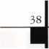

Keynotes

May 2000

Associate members of the Associated Locksmiths of America (ALOA) manufacture or distribute materials or equipment, or provide services, for the security industry. Many have donated money, services and equipment to ALOA in addition to their annual dues. Their support of ALOA projects enhances overall membership benefits and we encourage our members to patronize these firms. If you know of a potential candidate for associate membership, please contact the ALOA Membership staff at (800) 5 32-ALOA. Associate member dues are $300 per year and entitle the payor to use the ALOA logo, and receive selected discounts on ALOA products and services.

Legend

® Alarms: Personal, vehicle, electronic, fire, burglar, and exit

@ Bank security equipment

® Automotive: Lockout equipment, key chains/rings

*§ Builders Hardware: Door closers, furniture/decorative hardware, viewers, emergency exit devices

® Business/Technical & Educational:

Books, reference guides, publications, computer software

® CCTV/Photo Imaging: Cameras, monitors, photo ID equipment, cables

II Electric/Electronic Security: Card access control and readers, surveil­lance, electric/magnetic locks and strikes, keypads

® Lock Devices: Auto locks, cylinders, emergency exit/entrance control, locks (various types), strikes

® Tools & Supplies: Key blanks, cutters, picks, rings/hooks, custom van/truck supplies

© Safes/Vaults

© Other

|  |  |  |
| --- | --- | --- |
| Don-Jo Manufacturing, Inc.  P.O. Box 929  Sterling, MA 01564 (508)422-3377; FAX (508) 422-3467 | Intellikey  551 S. Apolo Boulevard, Suite 204  Melbourne, Florida 32901 (800) 226-0703; FAX (407) 724-0811 | Medeco Security Locks  P.O. Box 3075  Salem, VA 24153  (540)380-5000; FAX (540) 380-5010 |
| • • |  | • • • |
| Door Controls International  2362 Bishop Circle East  Dexter, Ml 48130  (800)742-3634; FAX (800) 742-0410 | KABA High Security Locks  P.O. Box 490  Southington, CT 06489 (860) 621 -3601; FAX (860) 621 -9727 | Meilink Safe Company  111 Security Parkway  New Albany, IN 47150 (800) 634-5465; FAX (800) 896-6606 |
| • • • • | • | • |
| ESP Lock Products, Inc.  375 Harvard Street  Leominster, MA 01453 (978) 537-6121; FAX (978) 534-9109 | KEY-BAK; Dhr. of W. Coast Chain Mfg. Co.  1460 S. Balboa Ave.  Ontario, CA 91762 (909) 923-7800; FAX (909) 923-0024 | National Cabinet Lock  200 Old Mill Road, P. O. Box 200  Mauldin, SC 29662 (864) 297-6655; FAX (864) 297-9987 |
| 11 | • • • • | • |
| Folger Adam Security, Inc.  16300 W. 103rd Street  Lemont, IL 60439  (630) 739-3900; FAX (630) 739-6138 | Knaack Manufacturing Co.  420 E. Terra Cotta Ave.  Crystal Lake, IL 60014 (800) 456-7865; FAX (815) 459-9097 | Newman Tonks  805 N Buckman St.  Shepardsville, KY 40165 (800) 826-5792; FAX (800) 777-8229 |
| • • | • | • • |
| Fort Lock Corp.  3000 N. River Rd.  River Grove, IL 60171 (708) 456-1100; FAX (708) 456-9476 | LAB Security  700 Emmett St.  Bristol, CT 06010  (800) 243-8242; FAX (203) 583-7838 | ROFU International Corp.  2004-B 48th Ave.; Court E  Tacoma, WA 98424 (800) 255-7638; FAX (253) 922-1728 |
| • ••••• | • | • • • |
| Grobet File Co. of America  750 Washington Ave.  Carlsladt, NJ 07072 (800) 962-7242; FAX (800) 243-2432 | LCN Closers (Division of Ingersol)  121 W. Railroad Ave.  Princeton, IL 61356  (815) 875-3311; FAX (815) 875-3222 | Rutherford Controls Inc.  2697 International Pkwy, Bid 5 #100  Virginia Beach, VA 23452 (757) 427-1230; FAX (757) 427-9549 |
| • | • | • |
| H.E.S., Inc.  2040 W. Quail Ave.  Phoenix, AZ 85027 (602) 582-4626; FAX (602) 582-4641 | La Gard, Inc.  3330 Kashiwa Street  Torrance, CA 90505 (310) 325-5670; FAX (310) 325-5615 | STRATTEC Security Corp.  3333 W. Good Hope Rd.  Milwaukee, Wl 53209 (414) 247-3333; FAX (414) 247-3329 |
| (0 (Q | • • • | • • • |
| HPC, Inc.  3999 N. 25th Avenue  Schiller Park, IL 60176 (847) 671 -6280; FAX (847) 671-6343 | Lucky Line Products  7890 Dunbrook Rd.  San Diego, CA 92126 (619) 549-6699; FAX (619) 549-0949 | Sargent & Greenleaf, Inc.  P.O. Box 930  Nicholasville, KY 40340-0930 (606) 885-9411; FAX (606) 887-2057 |
| • • • | • | • • • • |
| HID Corporation  9292 Jeronimo Road  Irvine, CA 92618  (949) 568-1600; FAX (949) 568-1680 | M.A.G. Engineering & Mfg. Inc.  15261 Transistor Lane  Huntington Beach, CA 92649 (714) 891-5100; FAX (714) 892-6845 | Schlage Lock Co.  1915 Jamboree Suite 165  Colorado Springs, CO 80920 (800) 847-1864; FAX (800) 452-0663 |
| • • | • • • | • • |
| Hongtai Lock Co. Ltd.  Jidong, Xiaolan Road, Xiolan Zhongshan/Guangdong, China 528415 (86) 137-238-1414; FAX (86) 208-793-3856 | MARKS USA  5300 New Horizons Blvd.  Amityville, NY 11701 (516) 225-5400; FAX (516) 225-6136 | Schwab Corporation  110 Professional Court  Lafayette, IN 47905 (765) 447-9470; FAX (765) 447-8278 |
| • • • • | • | • |
| llco Unican  400 Jeffreys Road  Rocky Mount, NC 27804 (252) 446-3321; FAX (252) 446-4702 | MUL-T-LOCK USA, Inc.  300-1 Route 17 South Suite A  Lodi, NJ 07644  (800) 562-3511; FAX (973) 778-4007 | Securitron Magnalock Corp.  550 Vista Blvd.  Sparks, NV 89434  (800) 624-5625; FAX (702) 355-5636 |
| ^ (01 @ (0 ^ | • • • | • # |
| In Out Systems, Inc.  3650-B Matte Boulevard  Brossard, Quebec J4Y-2Z2, Canada (450) 444-5949; FAX (450) 444-4856 | Master Lock Company  2600 North 32nd Street  Milwaukee, Wl 53211 (414) 444-2800; FAX (414) 449-3114 | Security Door Controls  3580 Willow Lane  Westlake Village, CA 91361 (805) 494-0622; FAX (800) 959-4732 |
| • • | • • | • |
|  |  |  |

May 2000

Keynotes

|  |  |  |
| --- | --- | --- |
| Security Solutions  1640 W. Hwy. 152  Mustang, OK 73064 (405) 376-1600; FAX (405) 376-6870  g g g | DISTRIBUTORS | Direct Security Supply, Inc.  36 Lincoln Street  Boston, MA 02135  (800) 252-5757; FAX (800) 452-8600  g lg) g ig) g (g g |
| Sentry Group  900 Linden Ave.  Rochester, NY 14625-2784 (716) 381-4900; FAX (716) 381-8559  g | Accredited Lock Supply Co.  P.O. Box 1442  Secaucus, NJ 07096-1442 (800) 652-2835; FAX (201) 865-5031  g g g g g g g | Doyle Lock Supply  2211 W. River Road N.  Minneapolis, MN 55411 (800) 333-6953; FAX (612) 521-0166  ggggggggggg |
| Sully Tools Inc.  3515 Nodding Pine Ct.  Fairfax, VA 22033  (703) 689-3416; FAX (703) 787-0869  g g g | Ace Lock & Security Supply Co.  565 Rahway Ave.  Union, NJ 07083-6631 (800) ACE-LOCK; (800) ACE-FAX4  gggggggg | Dugmore & Duncan Inc.  30 Pond Park Rd.  Hingham, MA 02043 (888) 384-6673; FAX (888) 329-3846  g g lg) g g g g |
| Taymor Industries, Inc.  1586 Zephyr Ave.  Hayward, CA 94544 (800) 388-9887; FAX (800) 288-8133  g g | ADI  263 Old Country Road  Melville, NY 11747 (516) 692-1000; FAX (516) 692-3457  g g g | E. L. Reinhardt Co., Inc.  3250 Fanum Road  Vadnais Heights, MN 55110 (800) 328-1311; FAX (612) 481 -0166  g g |g (g g g |
| Trine Products Corporation  1430 Ferris Place  Bronx, NY 10461  (718) 829-4796; FAX (718) 792-9127  g g g | Akron Hardware Consultants, Inc.  2579 South Arlington Road  Akron, OH 44319  (800) 321 -9602; FAX (800) 328-6070  g (0 g | Ewert Wholesale Hardware  4709 W 120th St  Alsip II 60658  (800) 451 -0200; FAX (708) 597-0881  lg) g (g g g |
| Unelko Security Systems Ltd.  14641 N. 74th Street  Scottsdale, AZ 85260 (480) 991-7272; FAX (480) 483-7674  g | American Security Distribution  4411 E. La Palma  Anaheim, CA 92807 (714) 996-0791; FAX (714) 579-3508  g g (0 g g g | Fairway Supply, Inc.  2631 Lombardy Lane  Dallas, TX 75220  (214)350-0021; FAX (214) 352-4299  g |g) g |g (g g g |
| Videx, Inc.  1105 NE Circle Blvd.  Corvallis, OR 97330 (541) 758-0521; FAX (541) 752-5285 | Andrews Wholesale Lock Supply  544 S. 9th St.  Lebanon, PA 17042-6608 (717) 272-7422; FAX (717) 274-8679  g | Foley-Belsaw Company  6301 Equitable Road  Kansas City, MO 64120 (800)821-3452; FAX (816) 483-5010  g ig) |g g |
| W-Lok Corporation  675 East 16th Street, Suite 111  Holland, Ml 49423  (616) 355-4015; FAX (616) 355-4295  © | Boyle & Chase Inc.  P. O. Box 74  Accord, MA 02018-0074 (800) 325-2530; FAX (800) 205-3500  ^gl (g) | Fried Brothers, Inc.  467 N. 7th St.  Philadelphia, PA 19123 (800) 523-2924; FAX (800) 541 -3489  gggggggggg |
| Weiser Lock Company  6700 Weiser Lock Blvd.  Tucson, AZ 85746  (502) 741-6338; FAX (520) 741-6363  g g | Clark Security Products, Inc.  4775 Viewridge Ave.  San Diego, CA 92123-1641 (800) 854-2088; FAX (619) 974-5284  gggggggggg | HS&S Wholesale Distributors  12915 West 8 Mile Road  Detroit, Ml 48235  (800) 521 -2202; FAX (313) 342-7580  lg g g) |g |g g g |
| Wilson Bohannan Company  621 Buckeye Street  Marion, OH 43301-0504 (800) 382-3639; FAX (740) 383-1653  © | Cook's Building Specialties  2441 Menaul Blvd. NE; P.O. Box 37320 Albuquerque, NM 87176-7320 (505) 883-5701; FAX (505) 883-5704  g g g g g g | Hans Johnsen Company  8901 Chancellor Row  Dallas, TX 75247  (214) 879-1550; FAX (214) 879-1530  gggggggg |
| Yale Security Inc.  P.O. Box 25288  Charlotte, NC 28229-8010 (800) 438-1951; FAX (800) 338-0965  g g g g | DiMark International  3117 Liberator St., Unit A  Santa Maria, CA 93455 (800) 235-2435; FAX (805) 928-8034  g lg) (g g g | Hardware Agencies, Ltd.  1220 Dundas Street East  Toronto, ON M4M 1 S3 (416) 462-1921; FAX (414) 462-1922  gggggggg |
| Zhongshan Hua Feng Lock Products  S Yongning Industrial Road, Ziaolan Zhongshan Guangdong, China  86-760 227 82 63; FAX 86-270 227 80 63  © | Dire's Lock & Key Co.  2201 Broadway  Denver, CO 80205  (303) 294-0176; FAX (303) 294-0198  ggggggggggg | Hardware Suppliers of America  P.O. Box 2208  Winterville, NC 28590 (800) 334-5625; FAX (800) 334-5635  g g |



Keynotes

May 2000

|  |  |  |
| --- | --- | --- |
| IDN, Inc.  1000 S. Main, Suite 280  Grapevine, TX 76051 (817) 421 -5470; FAX (817) 421 -5468  0000000000 | Securite.com  4775 Viewridge Avenue  San Diego, CA 92123 (800) 241-3930; FAX (619) 974-5269  0 0 0 | Webster Safe & Lock Company, Inc.  3020 Millbranch  Memphis, TN 38116 (901) 332-2911; FAX (901) 332-2878  0 0 0 0 0 0 0 |
| Intermountain Lock & Supply Co  3106 South Main Street  Salt Lake City, Utah 84115 (800) 453-5386; FAX (801) 485-7205  0000000000 | Omaha Wholesale Hardware  1201 Pacific Street, PO Box 3628  Omaha, NE 68108 (800) 238-4566  00000000 | SERVICE |
| JLM Wholesale, Inc.  3095 Mullins Ct  Oxford, Ml 48371-1643 (800) 522-2940; FAX (800) 782-1160  0 (0 0 | Security Lock Distributors  40 A Street  Needham Heights, MA 02194 (800) 847-5625; FAX (800) 878-6400  0 0 0 | 1 -(800) Tow Truck, Inc.  190 Main Street  Hackensack, NJ 07601 (800) 835-4187; FAX (800) 835-4189 |
| Jo-Van Distributors Inc.  929 Warden Ave.  Scarborough, Ontario Ml L 4C6 (416) 752-7249; FAX (416) 752-3845  00000000000 | Sentry Security Fasteners  8109 N. University  Peoria, IL 61615  (309) 693-2800; FAX (309) 693-2872  • ® | Alarm Monitoring Service, Inc.  5021 Fairfield St.  Metairie, LA 70006 (504) 454-2163; (504) 456-8737  @ |
| Lockmasters, Inc.  5085 Danville Road  Nicholasville KY, 40356 (800) 654-0637; FAX (606) 885-7093  0 (0 0 0 | Southern Lock and Supply Co.  Box 1980, 10910 Endeavor Way  Pinellas Park, FL 33780 (800) 237-2875; FAX: (800) 447-2299  000000000 | Allstate Insurance Company  2775 Sanders Road, Suite A5  Northbrook, IL 60062 (847) 402-8196; FAX (847) 326-7509  ® |
| Locks Company  2050 N.E. 151 St.  N. Miami, FL 33162 (800) 288-0801; FAX (305) 949-3619  0 0 0 0 0 0 0 | Stone & Berg Wholesale  99 Stafford Street  Worcester, MA 01603 (800) 225-7405; FAX (800) 535-5625  0000000000 | Diamond Software  2952 N. Expressway  Griffin, GA 30223  (770) 227-7650; FAX (770) 227-1699  ® |
| The Locksmith Store Inc.  1229 E Algonquin Rd. Suite E  Arlington Heights, IL 60005 (847) 364-5111; FAX (847) 364-5125  0 (0 (0 (0 | Strauss Safe & Lock Company  1801 Second Avenue  Des Moines, IA 50314 (515)288-9571; FAX: (515) 288-9752  0 0 0 0 0 0 | Locksmith Publishing Corp.  850 Busse Hwy.  Park Ridge, IL 60068 (847) 692-5940; FAX (847)692-4604  • |
| M. Zion Company  69 Reade Street, 4th Floor  New York, NY 10007 (212) 349-8677; FAX (212) 964-0495  0 (0 (0 (0 0 (0 (0 | Tanner Bolt & Nut Corporation  4302 Glenwood Road  Brooklyn, NY 11210 (718) 434-4502; FAX (718) 434-3215  ® | The National Locksmith Magazine  1533 Burgundy Parkway  Stream wood, IL 60107 (630) 837-2044; FAX (630) 837-1210  ® |
| McDonald-DASH Locksmith Supply  5767 E. Shelby Dr.  Memphis, TN 38141 (800) 238-7541; FAX (901) 366-0005  00000000 | Timemaster, Inc.  127 SE 29th Street  Topeka, KS 66605  (785) 232-8705; FAX (800) 798-8463  0 0 0 0 0 0 0 | Pine Technical College  1000 4th Street  Pine City, MN 55063 (800) 521 -7463; FAX (320) 629-7603  ® |
| McManus Locksmith Supply, Inc.  P.O. Box 9231, 1309 Central Ave.  Charlotte, NC 28299 (702) 333-9112; FAX (704) 332-8664  0 0 (0 0 (0 0 | Top Notch Distributors, Inc.  3151 Goni Rd.  Carson City, NV 89706-7922 (800) 722-4210; FAX (800) 248-3620  0 0 0 | SecurityEdge.com  P.O. Box 990  Exeter, NH 03833  (603) 772-6645; FAX (603) 778-7265 |
| McMaster-Carr Supply Company  600 County Line Rd,  Elmhurst, IL 60126-2081 (630) 833-0300; FAX (630) 834-9427  0 0 0 0 0 0 | Turn 10  P. O. Box 746  Marietta, OH m45750 (800) 848-9790; FAX (800) 391 -4553  0 0 | ® Alarms  © Bank Security Equipment ® Automotive © Builders Hardware ® Business/Tech & Ed.  © CCTV/Photo Imaging © Electric/Electronic Security ® Lock Devices © Tools & Supplies © Safes/Vaults ® Other |
| Monaco Lock Co.  339-345 Newark Ave.  Jersey City, NJ 07302 (800) 526-6094; FAX (800) 845-LOCK  0 0 0 | U.S. Lock Corporation  77 Rodeo Drive  Brentwood, NY 11717 (800) 925-5000; FAX (800) 338-5625  0 0 0 0 0 |
|  |  |

May 2000

Keynotes L

Keynotes

Authors

Dept

*Claire L. Cohen,* the second woman to become a CML, has been in locksmithing jfel since 1977 and has been writing articles | for Keynotes since 1987. She is also a contributing editor for Keynotes.



*Brian Costley,* CML, CMS was the  
1995 ALOA (ALOA Lifetime of  
Outstanding Achievement) Award winner  
and has been involved with the security  
industry for over 25 years. He’s contributed

to a variety of trade publications and is the director of  
Customer Services for Sargent and Greenleaf.

*Donald B. Dennis*, CPL has been dealing with the locksmithing profession since 1972 with a four year apprenticeship in Albuquerque, New Mexico. He founded and has been the owner of Dennis Safe & Lock in Johnson City, Tennessee since 1977. He was the founder of the East Tennessee Locksmith Association in 1988 and is currently the Chairman of the Education Committee and editor of ETLA Newsletter.



*Sal Dulcamaro,* CML, has been in the  
locksmith business for over 25 years. He is  
the president of All Pro Security, Inc. in  
Michigan and has been an ALOA member  
for 18 years. A past president of the

Locksmith Security Association of Michigan. Sal  
currently serves as editor of the association newsletter.

He was named “Keynotes Author of the Year” for 1996 and 1997. He is also a contributing editor for Keynotes.

|jfPH| *Tim McMullen* oversees legislative affairs I for ALOA. He is a graduate of the District I of Columbia School of Law and has an I W U extenswe background in legislative work.

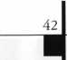

Keynotes

May 2000

|  |  |
| --- | --- |
| Keynotes  Advertisers Index | |
| Advertisers | Page |
| 800 Locksmith | 19 |
| A&B Safe | 17 |
| ALOA 2000 | 1 |
| Hickok | BC |
| llco Unican | IFC |
| Marray Enterprises | 16 |
| Masterlink Security | 31 |
| New Mexico  Locksmith Association | 32 |
| SafeTech 2001 | 33 |
| Safe Technicians  Reference Manual | 13 |
| Schlage | 5 |
| Security Lock | 11 |
| Stam Insight | IBC |
| Stone & Berg | 9 |
| Turn 10 Wholesale | 7 |
| UPP | 21 |



Members get the last word**...**

Every year Keynotes awards the “Author of the Year” to the author who has gone beyond the call of  
duty when submitting articles to the magazine. Since our members are a vital part of ALOA’s success,  
we’ve decided once again to let the award be decided by “Reader’s Choice!”

Review the list of articles below and select your favorite author. The first 25 voters will receive an  
ALOA cap. Cast your ballot today!

Thank you from the staff of Keynotes for your participation and from our authors for your support.



APRIL 99

The Locksmith Business Card Michael A. Ferrill Sometimes You Fall Into Something Good Claire Cohen What is Institutional Locksmithing Michael A. Ferrill New Security for Storefront Doors

Paul Chandler

Schlage Knob Cylinder Removal Without A Key

Sal Dulcamaro

Personal Security Devices from Americorp

*Sal* Dulcamaro

MAY 99

Have You Considered A Home Safe?

Claire Cohen

Meet The Time Commander Brian Costley Servicing Vault Locks Dan Graffeo Safe Lock Cleaning and Lubrication Don Demis

Kwikset Residential Keyed Levers

Sal Dulcamaro Mystery Safe

Michael A. Ferrill

JUNE 99

Breaking In To An Existing Master Key System Billy B. Edwards Jr.

The Locksmiths Liability Don Dennis Holding A Successful Keying Conference Jerome V. Andrews

Master Keying Software from Data Logic

Sal Dulcamaro

Edi-Lock

Poul Dyson

Bringing Ghost (Keys) to Life

Greg Perry

Locksmith Librarian

Michael A. Ferrill

JULY/AUG 99

Millennium Fever Claire Cohen Scattershooting Sal Dulcamaro More Electric Strike Options from HES Paul Chandler

The Future of Proximity Access Control Paul Chandler Olympus Old & New Don Dennis Souber Tools Sal Dulcamaro Made in America: Wilson Bohannan Michael A. Ferrill Schlage Redefines the Patented Key for Locksmiths A.J. Hoffman

SEPT 99

Home Security

Michael A. Ferrill

Alarm Basics

*Greg* Perry’

Crime Prevention: What Works?

Don Dennis

Security Technology and Privacy Sal Dulcamaro Gambling On A New Hire

George Sharpley

OCT 99

All Aboard

Don Dennis

Jackson Lock Manufacturing Michael A. Ferrill Determinator. I'll Be Back...With Your Car Keys!

Sal Dulcamaro A Guide for the Casual Automotive Locksmith Sal Dulcamaro Locksmith Librarian Michael A. Ferrill Mastering Your Job Search Clarie Cohen

NOV 99

Building An Ownership Culture in Your Business

Claire Cohen

Toolin Around-Unraveling the Weiserbolt Sal Dulcamaro New Tool for a New Era Don Dennis STRATTEC 2000 Sal Dulcamaro Fiber Optic Inspection Tool Sal Dulcamaro Tools of the Trade C.D. Lipscomb

DEC 99

Cincinnati Proximity

Paul Chandler

What Was HID Shall Be Found Paul Chandler STRATTEC 2000-Part 2 Sal Dulcamaro Good Things Come in Small Packages Paul Chandler Finding A Noble Niche Sal Dulcamaro The Woes of Inventory Don Demis

Suggestive Selling 101

Claire Cohen

JAN 2000

Arm-A-Dor Revisited Don Dennis Commercial Key-in Lever Locksets

Sal Dulcamaro

Antique Surface Mounted Rim Locks

Michael A. Ferrill

Lock In on Lock Outs

Billy Edwards

Padlock Inventory

Don Demis

FEB 2000

Hiring 101: Howto Hire A New Employee

Claire Cohen

So You Want To Be A Small Town Locksmith? Part 2 C.D. Lipscomb Locksmithing in the Information Age Paul Chandler The Credit Battle Don Dennis

MARCH 2000

Can E-mail Be Part of Your Marketing Strategy

Claire Cohen

Don't Get Caught In the Net

Paul Chandler

Growing Your Business

Claire Cohen

The Water Proof Trilogy from Alarm Lock

Sal Dulcamaro

Locksmiths Down Under

Michael A. Ferrill

Web Dreams

Don Demis

Please submit your vote to:

Keynotes Author of the Year, 3003 Live Oak Street, Dallas, TX 75204  
Name

My Selection for Author of the Year is

I selected this author because

My favorite story/stories and why

Fax (214) 827-1810 • E-mail: keynotes @anet-dfw.com Member Number

May 2000

Keynotes

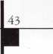

To: Tim McMullen; Charlie Gibson; publ@anet-dfw-com

Subject: A Special Thank You to ALOA

As many of you have read, Tennessee has been fighting bad legislation which would imprison by felony conviction any locksmith who duplicated a safe deposit box key.

Today, we visited many legislators and had meetings until 1:30 when the primary committee met. Leading the helm with many of us helping were Tim McMullen, Legislative Affairs Director of ALOA, Don Rule, Southeast Director of ALOA. We asked for help and ALOA delivered. These two were a class act and went neck and neck against well funded bankers and prevailed.

We may not be totally out of the water but the bill was sent to a subcommittee for “review.” Normally this means it will die. Tim spoke before a large group of senators, media and a big audience. He did so well that the opposing lobbyist got visibly red in front of everyone.

I just want to say that regardless of your views of ALOA, the current people are top notch. What other industry can you pay only $125 per year and get so much help when needed? We greatly appreciate all of the help Tim, Don and the ALOA Staff have been throughout this situation. Please sup­port the ALOA legislative fund, because this could happen to you next.

Also, thank you to Anne at Lockmasters for your helpful advice and action.

This just goes to show you how much we can rally together in a time of need and how much effect we can have when we work together.

I’ll keep you posted if anything develops.

Sincerely,

Tom Gillingham, CRL

President-Tennessee Organization of Locksmiths

44

***Keynotes***

May 2000



**HZEJ**

*Visit our Website on  
www. stamcctv. com*

THE COMPLETE

CCTV PROGRAM ON CD-ROM  
FOR STAFF TRAINING AND

PRODUCTIVITY ENHANCEMENT

STAM Insight has been

developed to enhance CCTV  
skills and productivity with

many different uses.

it Productivity

V System Drawing Estimation # CCTV Training H CCTV Reference It Sales/Demo it System Design It Staff Evaluation

CCTV Content

CCTV Calculators

Demonstration Tool

Estimation

Drawing

Internet Enabled

INFOMATE WORKMATE ULTIMATE

**Sold in Over 50 Countries**



! I Yes, please send me a FREE PREVIEW CD ROM - Send $9.95 Shipping and Handling

Name:

Job Title:

Organisation:

Zip/Postcode

Country e-mail

Tel: ( ) Fax: ( )

COPYRIGHT © 1996 Security Training and Marketing Pty Ltd. All rights reserved ACN 057 006 541

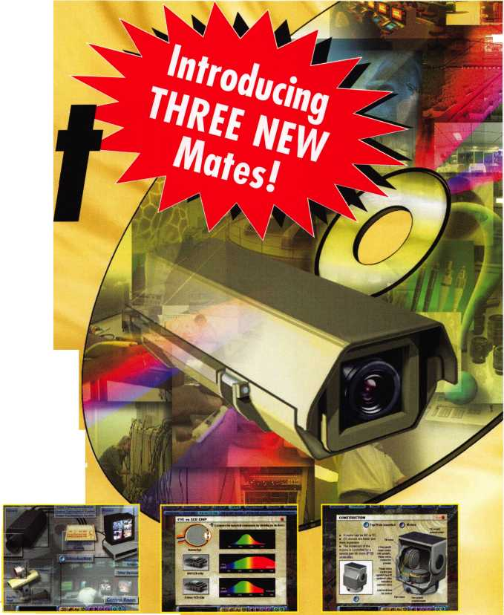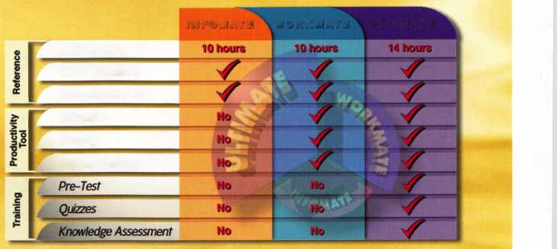

**Jump ahead of the competition  
at warp speed and see your profits soar.**

**Hickok’s New Generation STAR transports you with its advanced programming  
for keys to Ford-Lincoln-Mercury vehicles with passive antitheft systems.**

**Program vehicle keys through MY2000 with Hickok’s NGS Model 800-8 LA—$1995**

**HICKOK**

**INCORPORATED**

phone 800/342-5080  
[www.hickok-inc.com](http://www.hickok-inc.com)

- ,1

Sllli

|  |  |  |  |
| --- | --- | --- | --- |
|  |  |  |  |
|  |  | i— | i |
|  | 1 p ni^vi |  |  |
|  |  |  |  |

